Step-by-step Guide.

Avianca Airlines - Jeppesen Crew Pairing

Major Release 23 2018-01-31

Document Version 1.4

Table of contents

About This Document 4

Further Help 4

Conventions 4

Planning Work flow Overview 7

Planning Work flow Steps 11

1. Prepare Local Plans 12

1. Prepare Input Data and Program 12

2. Create new Local Plan 15

3. Build Aircraft Rotations 18

4. Prepare Leg Sets 20

5. Save Local Plan for every planning area in the 244

2. Work with Sub-Plans 255

1. Create Sub-Plan 25

2. Copy Feeds ETABs for the actual planning month and planning area 29

3. Set Planning period and Problem and synchronize data 31

4. Create carry-ins Sub-Plan with the NLC generated CTF file 35

5. Fetch the Carry-ins and the Start Sub-Plan and check the legality of the Sub-Plan 37

6. Create trips 46

3. Preparing Optimization 48

4. Export to Net Line Crew (NLC) 621

General Activities 64

Monitoring an Optimization Run 64

Fix NOPs 65

Leg Conflict Report 66

External Table Management 68

Copying External Tables Between Plans 68

Exporting External Tables to Source Directory 70

Importing External Tables to Current Sub-Plan 70

Advanced Copying of External Tables 71

Unix administration 72

CARMUSR and CARMDATA for AVA JCR prod 72

Publication data 72

Linking Timetables between different carmdata 72

Copying etables between different versions 73

# About This Document

This document gives detailed step-by-step instructions on how to perform planning with the Jeppesen Crew Pairing product, referred to as JCP.

#### Target Audience

The intended readers are:

* Planners
* Expert users
* Developers

#### Maintenance

This document is developed by Jeppesen Systems during an implementation project. At the handover, the ownership of this document is transferred to the client, who may continue to add information.

#### Version History

| Version | Release Date | Author | Comment |
| --- | --- | --- | --- |
| 1.0 | 2017-10-03 | Jesus Alderete | Initial draft |
| 1.2 | 2017-11-07 | Sergio Arellano | Updated File |
| 1.3 | 2018-01-03 | Jesus Alderete | Plan Naming Format |
| 1.4 | 2018-01-31 | Leticia Baez | Updated File |

### Further Help

This guide only includes the essential steps to perform a given procedure. For more information about commands, forms and general handling of the system, see the standard documentation and online help for Pairing.

### Conventions

This document uses the following conventions.

#### Tags

The following tags are used:

1. Matters of particular importance.
2. Cross-reference.

#### Type Styles

The following type styles are used:

|  |  |
| --- | --- |
| Italic | cross-reference |
| Bold | Jeppesen components; such as commands, names of buttons, boxes, field names and menu items |
| Courier | data and choices entered, such as file names, values and parameters |
| Initial Capitals | names of Carmen windows and services |
| > | sub-menu |

**Mouse**

This manual uses the following conventions to describe mouse actions:

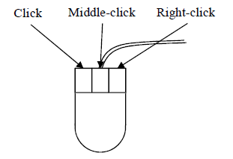

If the mouse only has two buttons, the middle-click action usually is performed by clicking the left and right buttons simultaneously.

# Planning Work flow Overview

The planning work flow described in this chapter is an implementation of the general pairing work flow described in the Jeppesen Crew Pairing User Guide. The details of the implementation are given in the Function Reference Manual under Planning work flow implementation.

#### General Work flow

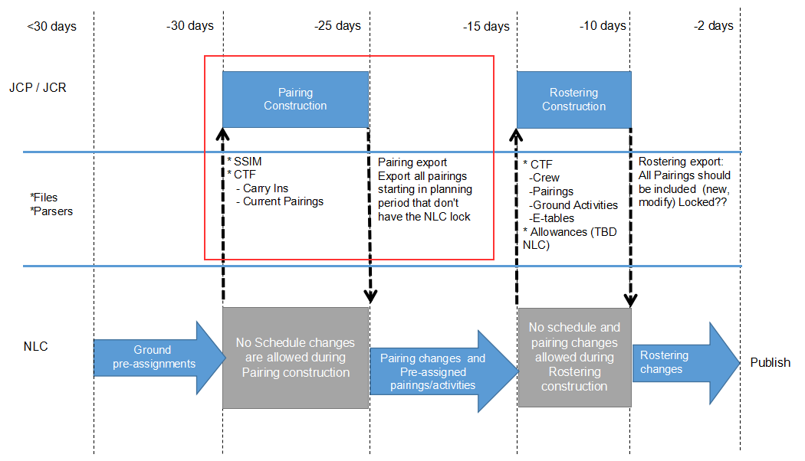

Figure 1:Overview of the Avianca planning work flow in Jeppesen Crew Pairing

#### Pairing Work flow LP

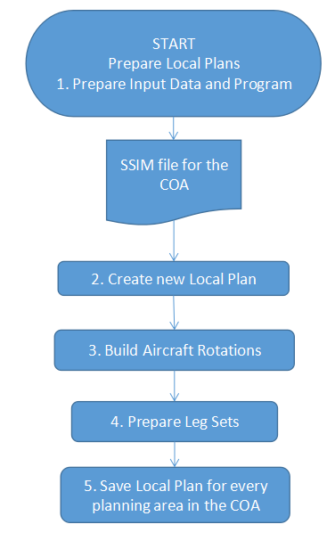

#### Pairing Work flow SP

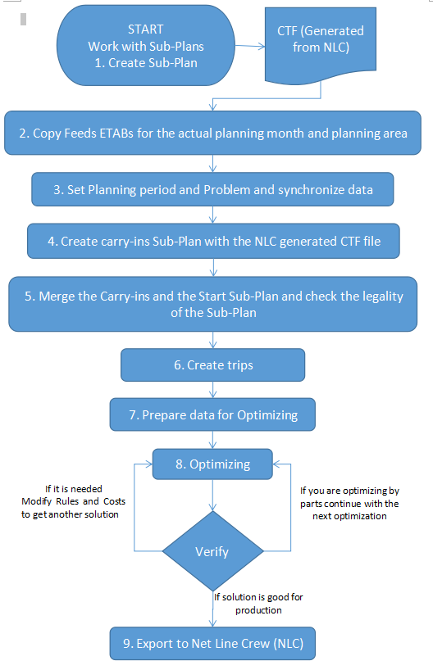

# Planning Work flow Steps

#### Sub-Plan Index

A lot of sub-plans are created during the planning stage. To help keep track of all operations in the steps, several of the commands add an index to every sub-plan created. The index starts at 999 and decreases for every step.

For some steps, the planner should manually save the plan with a new name. It is suggested that the same convention be followed for the manual saves: The most recent plan should always have the lowest number.

#### Planning Problem Identifier

* A planning problem has a unique combination of period, planning-area area and version.
* The period defines the time period, for example 201706_JCP for planning June 2017.
* The planning-area defines the problem that should be solved AOC, Category and AC type, for example AVA_FD_32S, TAI_CA_ALL.
* The version defines the version of the data used. In many cases, there is only one version of the data.

#### Local Plan Naming Recommendations

Syntax: ICAO’s AOC’s_category_fleet/YYYYMM_JCP/DATED_(n)

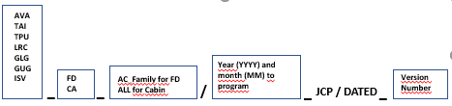

Examples:

AVA_FD_787/201802_JCP/DATED_01

AVA_CA_ALL/201802_JCP/DATED_01

TAI_FD_E90/201802_JCP/DATED_01

TPU_FD_32S/201802_JCP/DATED_01

LRC_CA_ALL/201802_JCP/DATED_02

## Prepare Local Plans

The steps detailed in this section will be followed every time that a SSIM file changed or is new, if the SSIM doesn’t change, continue or start from next section (Work with Sub-Plans) on every planning area that exist for the AOC that was worked with.

### Prepare Input Data and Program

In order to be able to create local and sub-plans, the necessary data need to be put in the correct locations:

Take Release notes as reference for project location:

The installation was done in the Avianca environment:

/opt/Jeppesen/share/ava/usr/jcr/prod/ava_jcp_jcr_user_prod/

* Ensure that SSIM data file for the planning problem is located in $CARMDATA/FP_FILES/
* Ensure that CTF data file for the planning problem is located in $CARMDATA/INTX_FILES/
* Process and move the SSIM and CTF data file to the correct locations in CARMDATA and set up soft links in CARMDATA pointing to this data. This is done from studio. For a thorough description of where the input files are being copied please consult the System Reference Manual.

Copy SSIM and CTF in the correct place.

The proposed naming convention is:

Incluir la forma en la que deben ser nombrados tanto el SSIM y el CTF

1. Copy the SSIM and place it in $CARMDATA/FP_FILES/

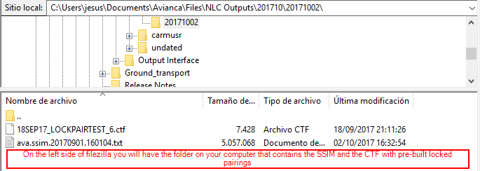

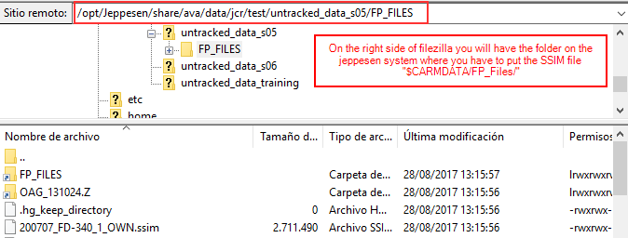

1. Copy the pre-built trips CTF and place it in $CARMDATA/FP_FILES/



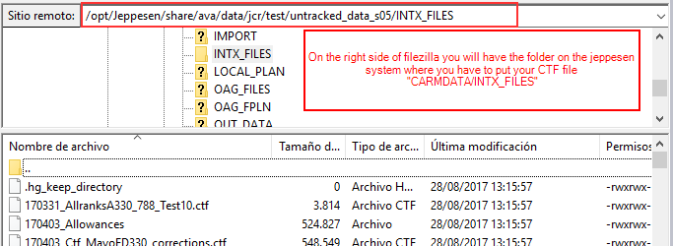

#### Load Ruleset and Parameters

1. Start **Studio**
2. To load AVIANCA JCP rule set, go to File(Alt+F) 🡪 Load(L) 🡪 Load Rule Set(R), and select default_jcp

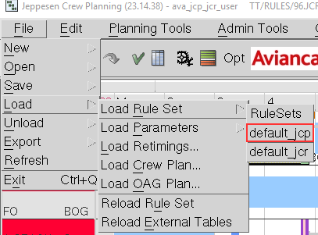

The rule set that was loaded will be shown in the window title:



1. To load Parameters File, go to File(Alt+F) 🡪 Load(L) 🡪 Load Parameters(P) 🡪 from File...(F)

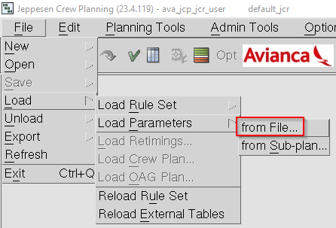

1. In the **Parameters Set Manager** window, go to the respective AOC **Directory** and in the **File** list, select the jcp parameters file, then click on **Load Settings** (Alt+L)

Example: AV_FD787 🡪 default_jcp_parameters

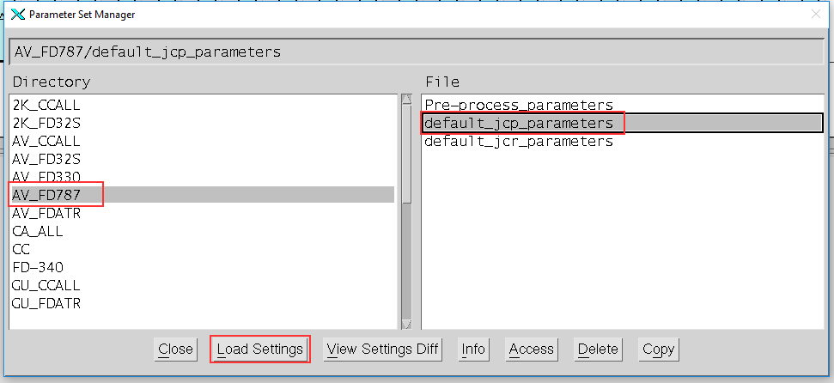

1. **Close** (Alt+C) the **Parameter Set Manager** window

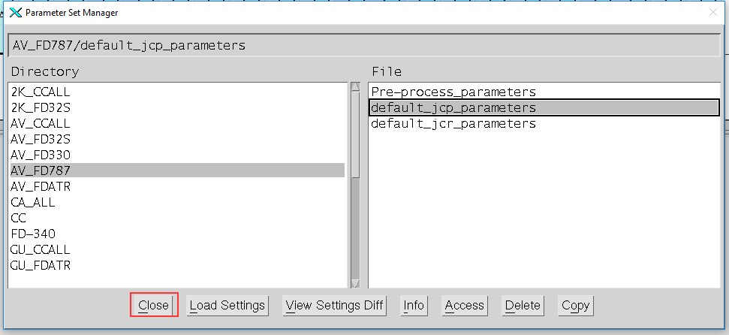

### Create new Local Plan

#### Generate the Local plan from the SSIM file

1. Go to File(Alt+F) 🡪 New(N) 🡪 New Local Plan(L) 🡪 from SSIM File...(S)

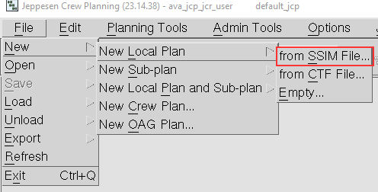

1. In **Create Local Plan** form, select tab **Main**, and enter the enter the necessary info in the fields marked in red (see the table below for further details)

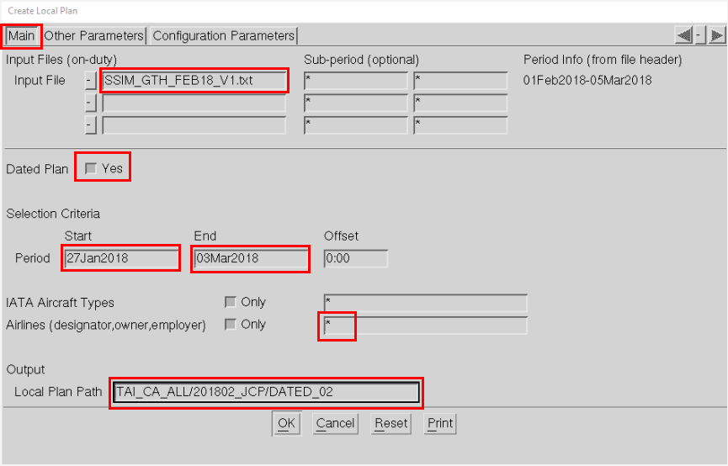

|  |  |
| --- | --- |
| Field | Definition |
| Input File | SSIM File (Ex. SSIM_GTH_FEB18_V1.txt) |
| Dated Plan | Make plan Dated or Weekly (Always Yes) |
| Period | Planning period with minimum 3 to 5 days of carry in and carry out (5 is recommended) (Ex. 27Jan2018 – 03Mar2018) |
| Airlines | AOC that is being worked with.  For AV, the value is AV  For T0 and TA, the value for this field is a star (*) |
| Local Plan Path | Name and path of the Local plan (JCP prefix means Jeppesen Crew Pairing). The name of the Local plan is composed by three parts separated by a “/”.  (Ex. AVA_FD_787/201802_JCP/DATED_01) |

1. Select tab **Other Parameters** and set to Yes, the parameters marked in red, then click **Ok** (Alt+O) to continue.

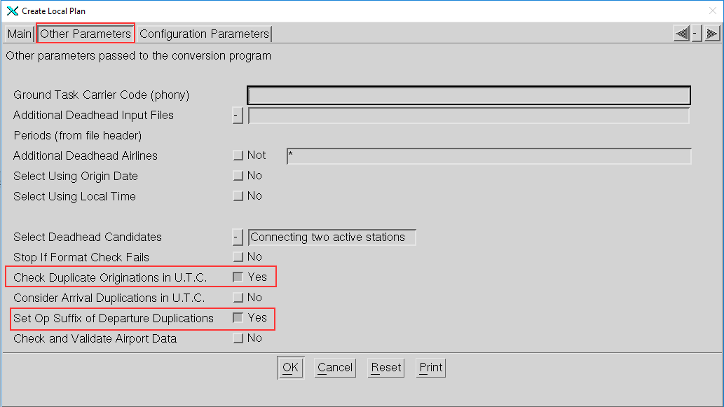

1. An information window will open with some logs of the created plan, it is recommended to verify the log contents to make sure that no leg-sets were discarded; an example of discarded leg-sets could me multi-leg flights with bad routing.

**Close** (Alt+C) the info window to continue 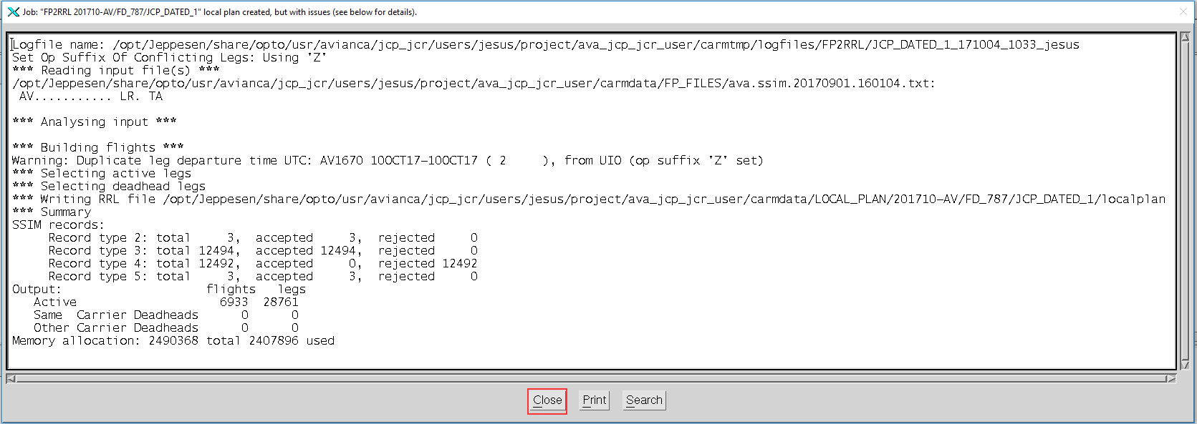

#### **Open Local Plan**

1. 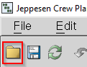Open the **Plan Manager** through **Planning Tools**(Alt+P) **🡪 Plan Manager**(P) or click

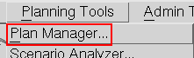

1. In **Plan Manager** window, go to the path Timetables 🡪 Version 🡪 Local Plan, then select the Local Plan and click **Open Plan** (Alt+P) to continue

Example: AV_FD_330 🡪 201701_JCP 🡪 DATED_01

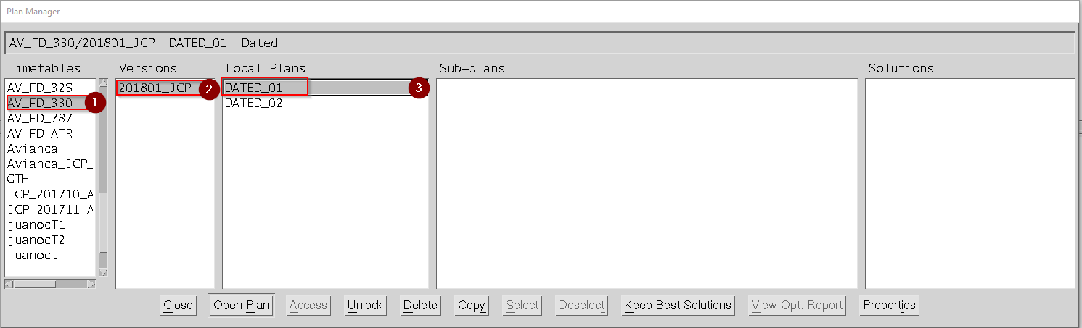

1. **Close** (Alt+C) the **Plan Manager** window

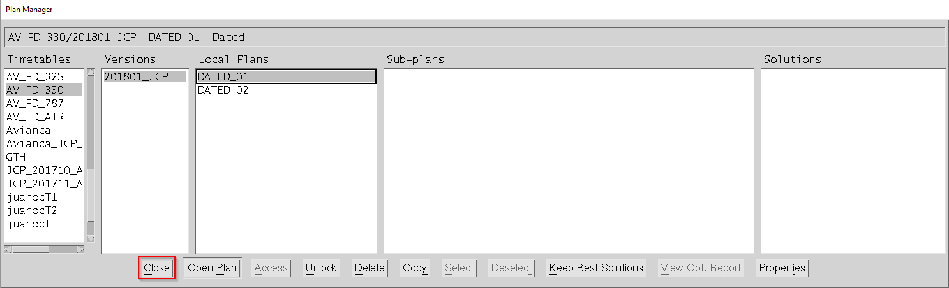

### Build Aircraft Rotations

#### Set rotation parameters

1. Go to **Planning Tools** (Alt+P) **🡪 Rule Parameters ...** (R)or click to open the **Rule Parameters** form

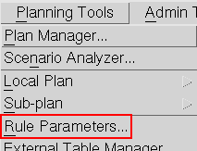

1. Select the tab **AC Rotations Build** and make sure the parameters in the red box are set as shown, then click **Ok** (Alt+O) to continue

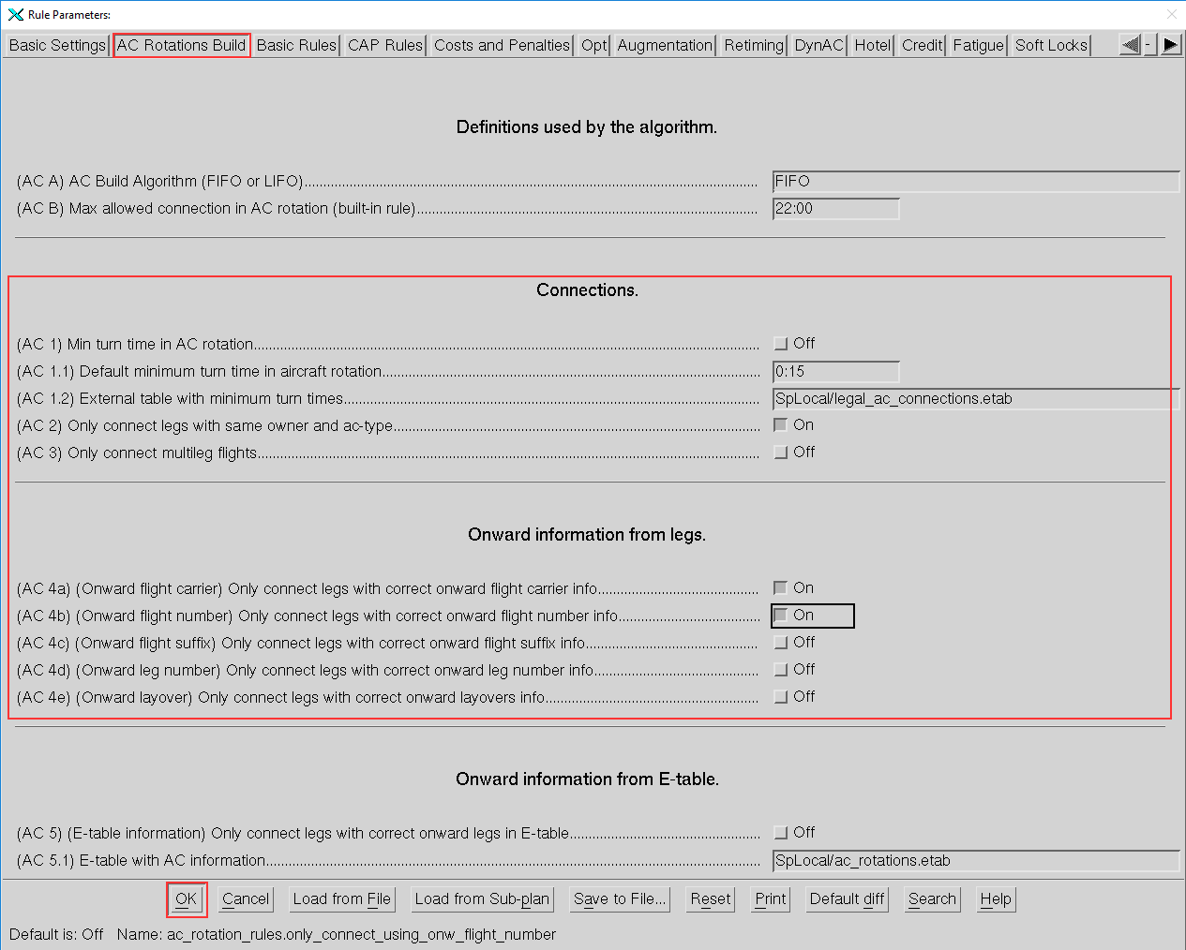

1. Go to Planning Tools(Alt+P) 🡪 Local plan(L)🡪 Build Rotations(B)

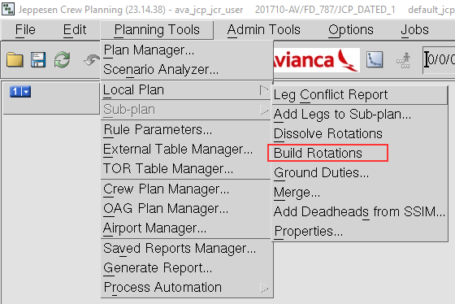

1. Click on the Window 1 icon and Select **Show Rotations** (or press **F6**)

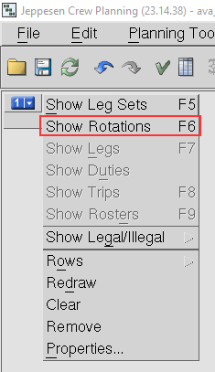

1. Verify that the *Rotations* were built properly.

Point the mouse over a leg and use the right arrow to verify on the display window that the Aircraft Type is the same for the same Aircraft Rotation.

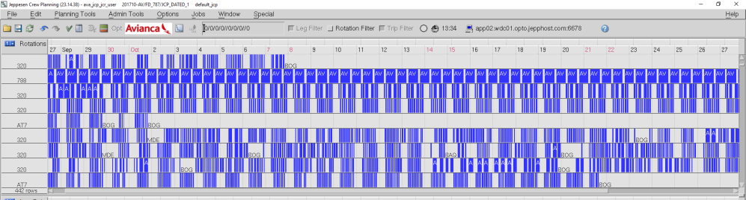

1. Go to File (Alt+F) 🡪 Save(S) and select to Save Local Plan(L)

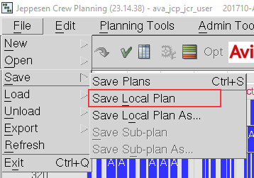

|  |  |
| --- | --- |
| *Note* | If you change the Rotations parameters or you see that some Rotations or want to re-make the Rotations go to Planning Tools(Alt+P) 🡪 Local plan(L)🡪 Dissolve Rotations and then repeat this section. |

### Prepare Leg Sets

#### **Clean Leg Sets**

1. Click on Window 1 icon and select to Show Leg Sets (or press F5)

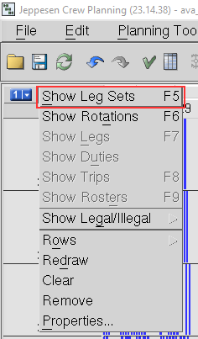

1. Right click on the Window 1 area (Not on a leg set) to open the Leg Set General menu, then select Filter 🡪 by...(b), (or press **Ctrl+F**)

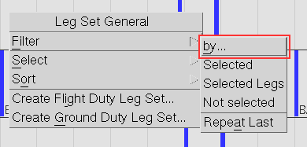

1. In **Leg Set Filter** form, (1) click on **Default** button (Alt+D); (2) in **Select** option, set Leg; (3) in **Service Type** field, enter ‘P’; (4) click on **Ok** button (Alt+O). If any Leg Sets with service type “P” is displayed, go to Step 4, else, skip to Step 6

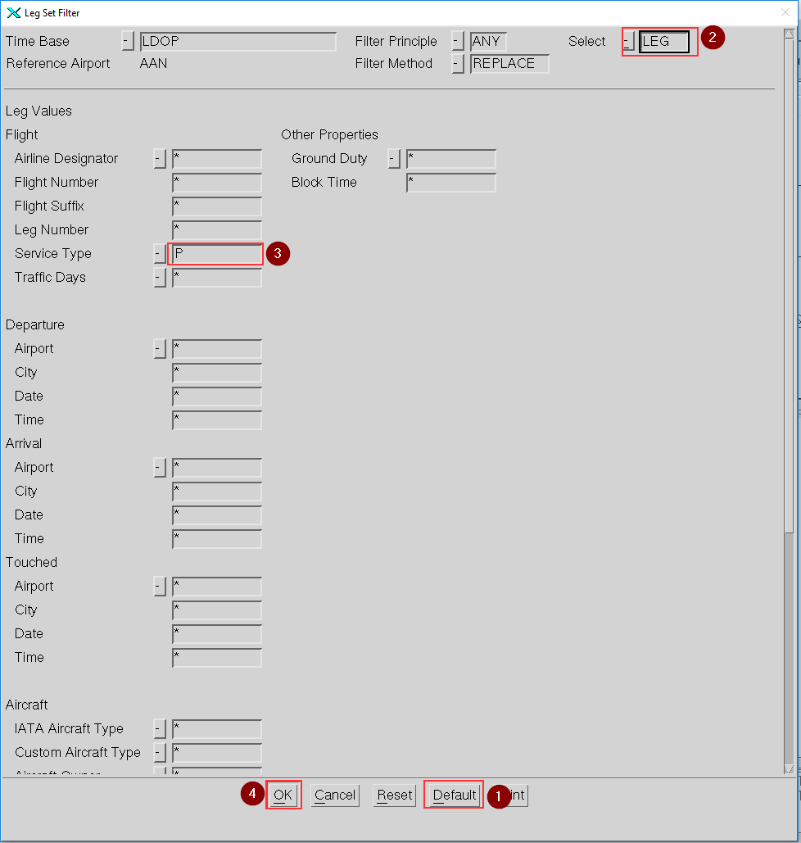

1. Right click on a Leg Set on **W**indow 1 to open the Leg Set Object menu, and select Delete(D)

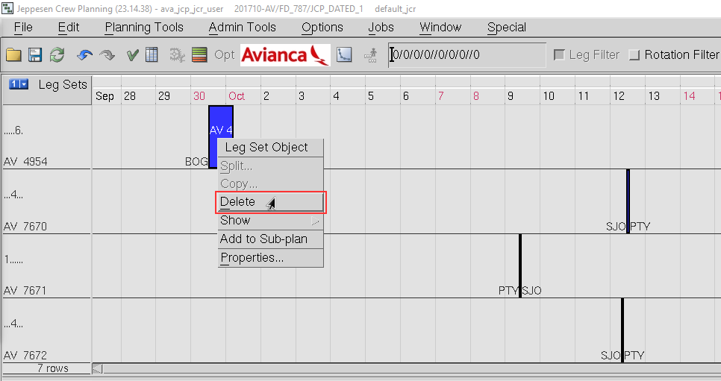

1. A **Choice** window will request a confirmation to remove the legs from local plan, Click on **Yes** (Alt+Y) to continue.

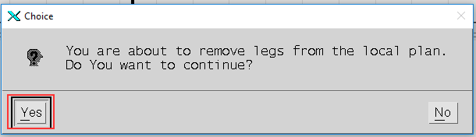

**NOTE: The next steps only apply to AV for the rest of ACOs, skip to section 5. Save Local Plan.**

1. Click on **Window 1** icon and select to **Show Leg Sets** (or press **F5**)



1. Right click on the Window 1 area (Not on a leg set) to open the Leg Set General menu, then select Filter 🡪 by...(b), (or press **Ctrl+F**)



1. In **Leg Set Filter** form, (1) click on **Default** button (Alt+D); (2) in **Select** option, set Leg; (3) in **Arline Designator** field, enter ‘!AV’ (! means different than); (4) click on **Ok** button (Alt+O). If any Leg Sets with Airline Designator different than “AV” are displayed on window 1, go to Step 9, else, jump to *Create deadhead Leg Sets* section.

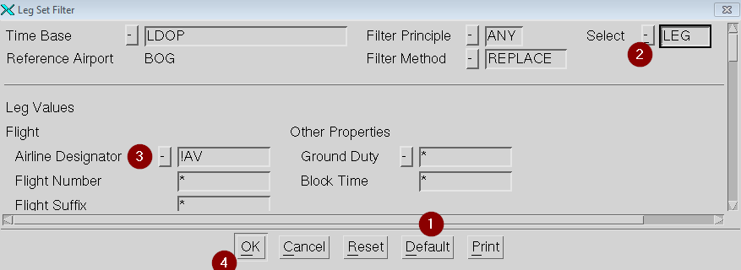

1. Right click on a **Leg Set** on **Window 1** to open the **Leg Set Object** menu, and select **Delete**(D)



1. A **Choice** window will request a confirmation to remove the legs from local plan, Click on **Yes** (Alt+Y) to continue



**Create deadhead Leg Sets**

1. Click on **Window 1** icon and select to **Show Leg Sets** (or press **F5**)



1. Right click on the Window 1 area (Not on a leg set) to open the Leg Set General menuand select to Create Flight Duty Leg Set... **(i)**

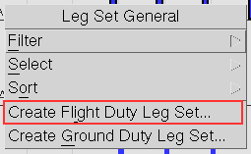

In the **Flight Duty Leg Set Properties** form, enter the information for flight AV8383 as shown below and then click **Ok** (Alt+O) to continue 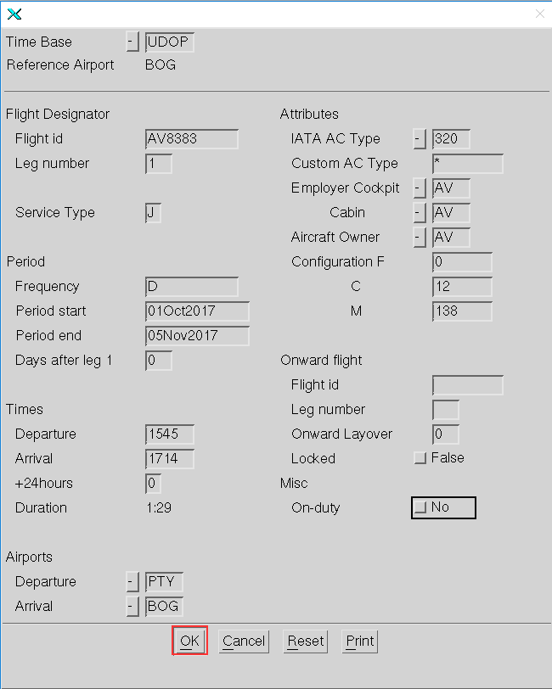

1. Right click on the **Window 1** area (Not on a leg set) to open the Leg Set General menu and select to **Create Flight Duty Leg Set... (i)**



1. In the **Flight Duty Leg Set Properties** form, enter the information for flight AV8380 as shown below and then click **Ok** (Alt+O) to continue

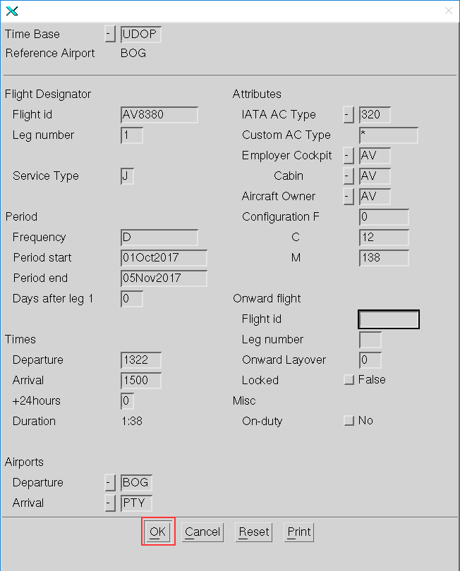

1. Go to **File** (Alt+F) **🡪 Save**(S) and select to **Save Local Plan**(L)



### Save Local Plan for every planning area in the AOC

Save Local Plan for every planning area in the AOC (As long the Local plan is the same for every planning area this step is highly recommended)

1. Go to **File** (Alt+F) **🡪 Save**(S) and select to **Save Local Plan As**(o)

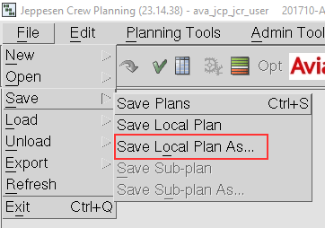

1. In the **Local Plan properties** form, adjust the Local Plan name (shown with red box in image below) according to planning area.

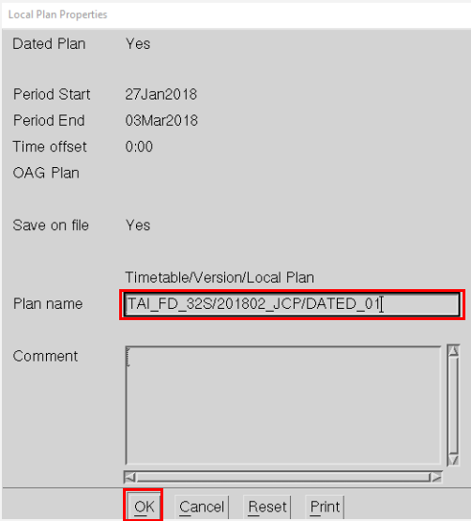

|  |  |
| --- | --- |
| Pairing Planning Area | for |
| CA_ATR | Cabin ATR |
| CA_ALL | Cabin for the rest of the fleets (B787, A330, A320, A319, A318, E90) |
| FD_32S | Pilots A320, A319 and A318 |
| FD_321 | Pilots A321 |
| FD_330 | Pilots A330 and A332 |
| FD_787 | Pilots B787 and B788 |
| FD_ATR | Pilots ATR |
| FD_E90 | Pilots E90 |

1. After changing the version for every planning area click **Ok** (Alt+k)
2. If the SSIM doesn’t change, continue from the next point on every planning area that exist for the AOC that was worked with.

## Work with Sub-Plans

### Create Sub-Plan

#### Add the Legs from the AC Family you are working with to Sub-Plan

1. Go to **Planning Tools**(Alt+P) **> Plan Manager**(P) or click to open the **Plan Manager** form



1. Select a **Timetables**/**Versions** folder for the planning area you are working with, and select a local plan to use in the **Local Plans** list, then click on **Open Plan** (Alt+P)

Example: (1) AV_FD_787 🡪 (2) 201801_JCP 🡪 (3) DATED_01

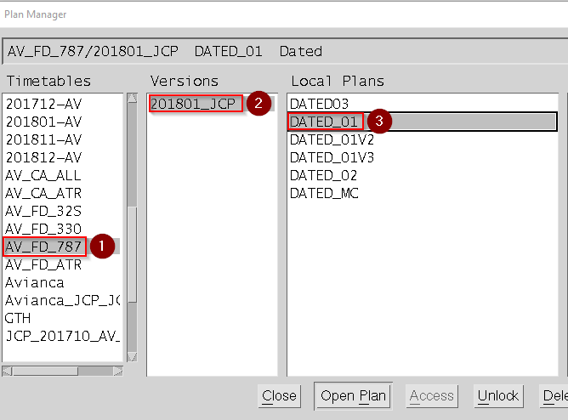

1. Click on **Close**(C) button to continue

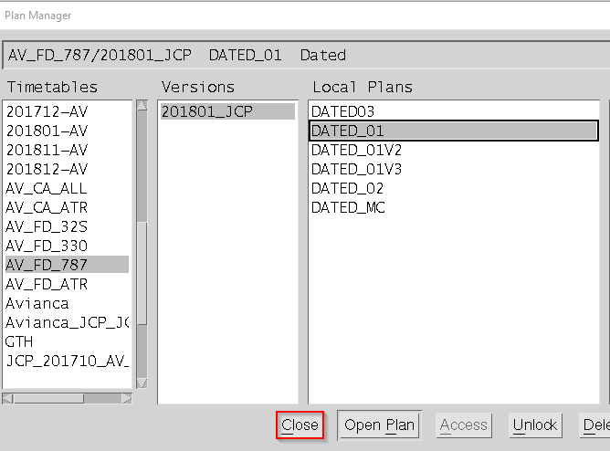

1. Click on **Window 1** icon and select to **Show Leg Sets** (or press **F5**)



1. Right click on the **Window 1** area (Not on a leg set) to open the Leg Set General menu, then select Filter 🡪 by...(b), (or press **Ctrl+F**)



1. In **Leg Set Filter** form, click on **Default** button (Alt+D); in **Select** option, set Leg; in **Departure|Date** field, enter ‘>=’ and the Planning Period Start Date (ex. >=01Oct2017); in **IATA Aircrat Type** field, enter the appropriate equipment type (examples in table below).

For Cabin, when the AOC is T0 or TA, fill the field Employer Cabin with the values T0 or TA accordingly.

For FD, when the AOC is T0 or TA, fill the field Employer Cockpit with the values T0 or TA, accordingly.

then click on **Ok** button (Alt+O).

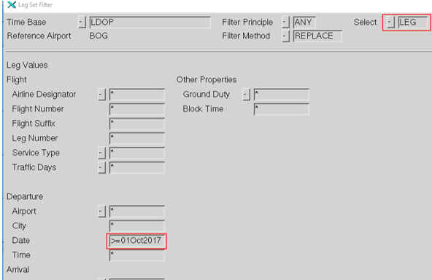

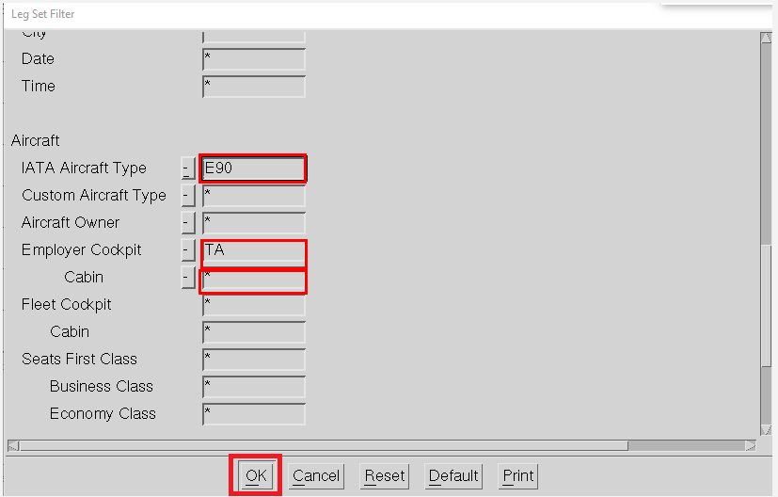

|  |  |
| --- | --- |
| IATA Aircraft Type | Enter values |
| **FD_320\*** | 318**,** 319**,** 320 |
| **FD_321** | 321 |
| **FD_330** | 330, 332 |
| **FD_787** | 787, 788 |
| **FD_ATR** | AT7 |
| **FD_E90** | E90 |
| **CA_ATR\*\*** | AT7 |
| **CA_ALL** | !AT7*** |

*This FD cover the three fleets for the PAIRING MODULE

** This applies to AV

***All fleets except AT7 – This applies to AV

Note: For Cabin, when the AOC is T0 or TA, the field IATA Aircraft Type is empty

1. Right click on a **Leg Set** on **Window 1** to open the **Leg Set Object** menu, and select Add to Sub-Plan

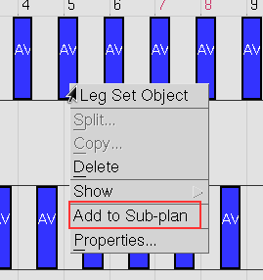

1. In the **Sub-plan Properties** form, enter the necessary data -marked with red box below- for the planning area that it is being work, then click **Ok**(Alt+O) to continue.

See the tables below for further details.

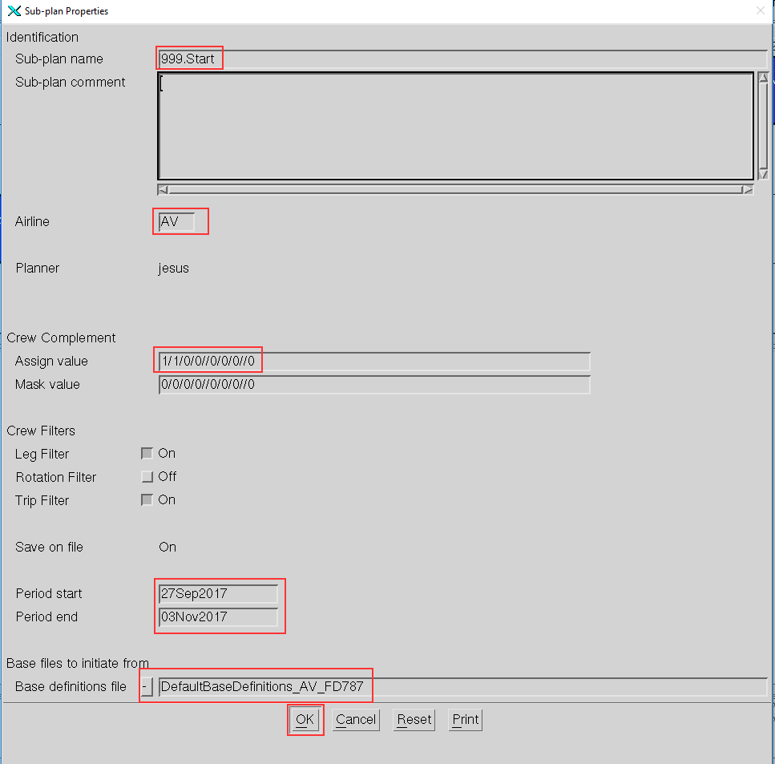

|  |  |
| --- | --- |
| Field | Definition |
| Sub-Plan Name | First sub-plan (Ex. 999.Start) |
| Airline | For AOC AV, the value is AV, for T0 and TA, this field is empty |
| Assign value | BaseDef-Files, there is one for each problem per AOC (Ex. 1/1/0/0//0/0/0//0) |
| Period start | Start of the planning period minus minimum 3 to 5 days of carry in (5 is recommended) (Ex. 27Sep2017) |
| Period end | End of the planning period plus minimum 3 to 5 days of carry out (5 is recommended) (Ex. 03Nov2017) |
| Base Definitions File | BaseDef-Files, there is one for each problem per AOC (Ex. DefaultBaseDefinitions_AV_FD787) |

Assign value for each planning area, should be the following:

|  |  |
| --- | --- |
| IATA Aircraft Type | Enter values |
| **FD_320**  **FD_321**  **FD_330**  **FD_787**  **FD_ATR** | 1/1/0/0//0/0/0//0 |
| **CA_ATR** | 0/0/0/0//0/2/0//0 |
| **CA_ALL\*** | 0/0/0/0//0/3/0//0 |
| **CA_ALL\*\*** | 0/0/0/0//1/2/0//0 |

*This applies to AV

**This applies to T0 and TA

A **Message** window might open informing that it “*Failed to load etable because table was not found*”, since the Feeds Etabs hasn’t been synchronized yet, it’s expected, Close the pop up window to continue.

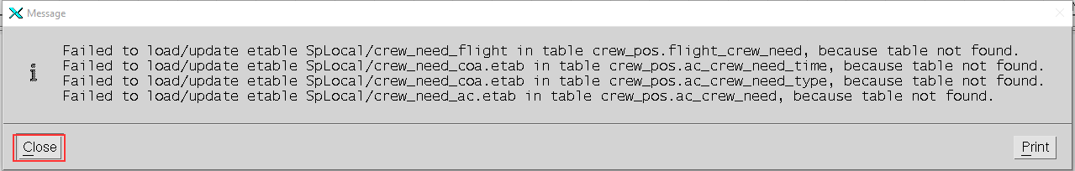

1. Go to **File**(Alt+F) 🡪 **Save**(S) and select to **Save Sub-Plan**(S)

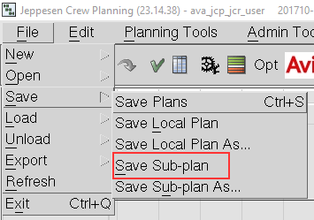

### Copy Feeds ETABs for the actual planning month and planning area

#### Copy the feeds ETABs from last month’s

Go to Planning Tools(Alt+P) 🡪 Process Automation(r) 🡪 Pairing(P) and select **Copy feeds ETABs**

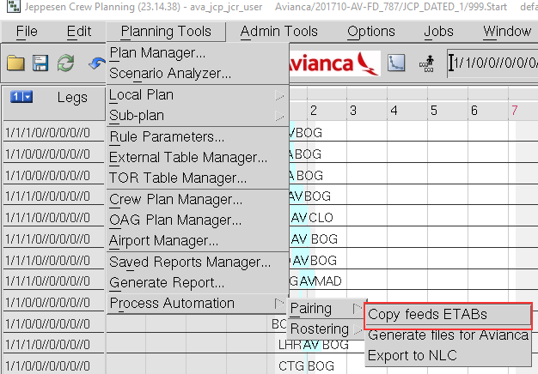

1. In **Select the month to plan, COA and Fleet** form, enter the values as necessary and the click **Ok** (Alt+O)

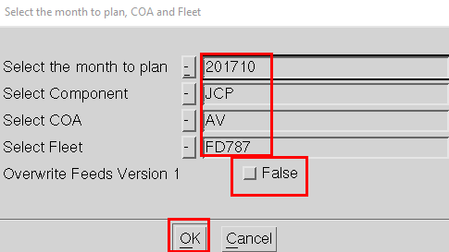

| Field | Definition |
| --- | --- |
| Select the month to plan | Planning month (Ex. 201710) |
| Select Component | JCP |
| Select COA | COA (Ex. AV) |
| Select Fleet | Fleet (Ex. FD787) |
| Overwrite Feeds Version 1 | If True the Feeds ETABs version will be 1, If False it will be the highest actual version plus 1 |

1. A **Message** window will pop up to inform version of the feeds ETABs for the planning month and planning area you are going to use, review the info and click **Close** (Alt+C) to continue

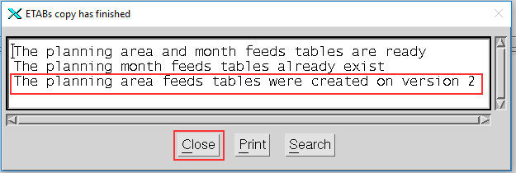

### Set Planning period and Problem and synchronize data

#### Set planning period and problem

1. Go to **Planning Tools**(Alt+P) 🡪 **Sub-plan**(S) 🡪**Set Planning Period and Problem…**(l)

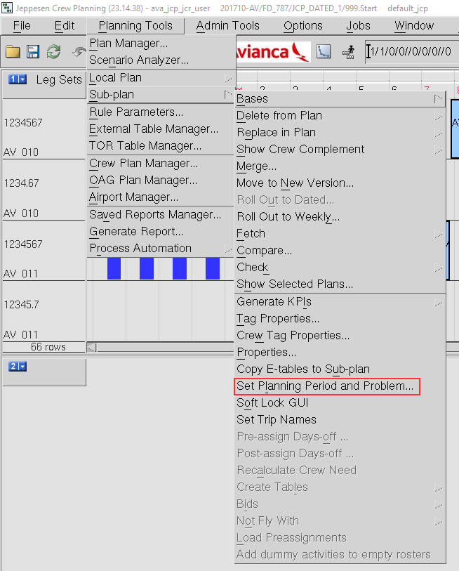

1. In **Set Planning Period and Planning Problem** form, enter the necessary values (marked in red box below) and click **Ok** (Alt+O) to continue:

See the table below for the description of each field

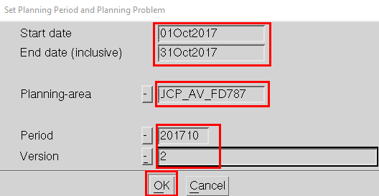

|  |  |
| --- | --- |
| Field | Definition |
| Start date | Starting day of the planning period. (Ex. 01Oct2017) |
| End date (inclusive) | Last day of the planning period (auto-filled once you input the Start date). (Ex. 31Oct2017) |
| Planning-area | AOC_crew_category(*CA for cabin, FD for flight deck*)fleet(*ALL for cabin ac_family for flight deck*). (Ex. AV_FD787) |
| Period | YYYYMM *(Planning month).* (Ex. 201710) |
| Version | Version of the data, the planning month data was copied on the last section and a version number was given, use that version number. (Ex. 1) |

#### Synchronize data

1. Go to **Planning Tools**(Alt+P) 🡪 **Sub-plan**(S) 🡪**Copy E-tables to Sub-plan**(u)

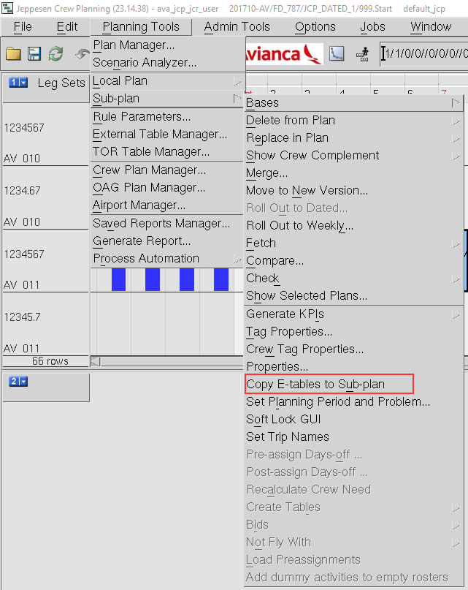

1. A **Message** window will open, with a list of the E-tables that were copied to the sub-plan and from which folder, once reviewed, click on **Close**(Alt+O) to continue

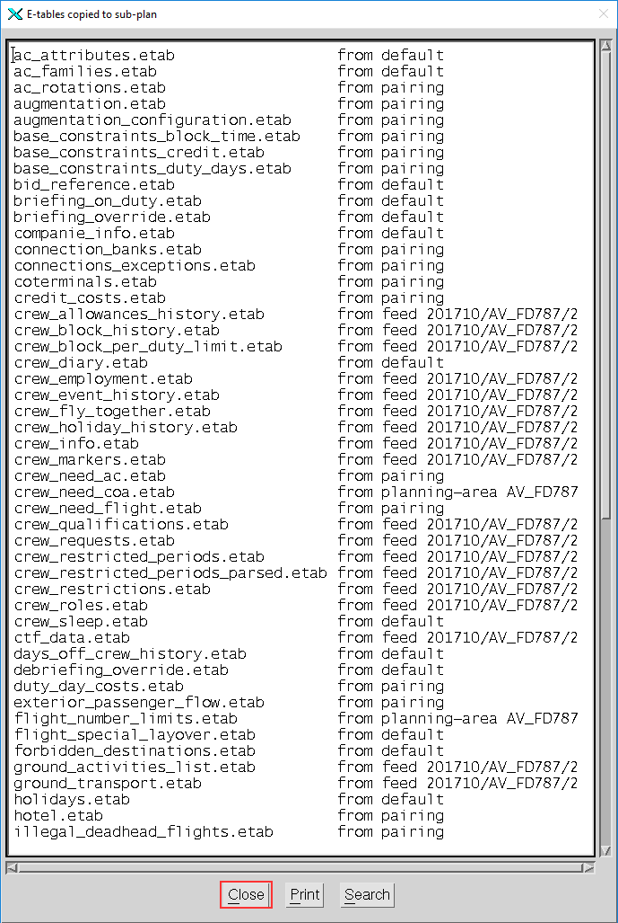

1. Verify that all the needed E-tables were copied, in order to do this, find in the tool bar the ETABs Notification icon, at the left side of the clock.

| Icon | Definition |
| --- | --- |
|  | There are missing E-tables in the sub-plan. |
|  | There is an error, missing properties in the subplan, or there differences between the loaded E-Tables and the default E-Tables. |
|  | E-tables are in sync. |

Before continue, the **ETABs Notification light** must be in green.

#### Reload parameters, If on production update this section to use last month parameters – **Only by request of Avianca.**

1. Go to File(Alt+F) 🡪 Load(L) 🡪 Load Parameters(P) 🡪 from File...(F)Load Parameters from File



1. In the **Parameters Set Manager** window, go to the respective AOC **Directory** and in the **File** list, select the jcp parameters file, then click on **Load Settings** (Alt+L)

Example: AV_FD787 🡪 default_jcp_parameters



1. **Close** (Alt+C) the **Parameter Set Manager** window



1. Go to **File** (Alt+F) **🡪 Save**(S) and select to **Save Sub-Plan**(S)



### Create carry-ins Sub-Plan with the NLC generated CTF file

#### Create Sub-Plan from CTF file generated from NLC

1. Go to File(Alt+F) 🡪 New(N) 🡪 New Sub-plan(S) and select from CTF File...(C)

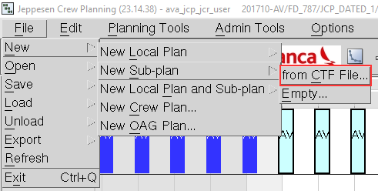

1. In the **Create Plan from CTF File** form, enter the necessary data
2. Fill in the input for planning period and problem form and click Ok:

Using the CTF file with carry-ins and locked pairings generate a Sub Plan inside the Local Plan that you have been working with

See the table below for the description of each field

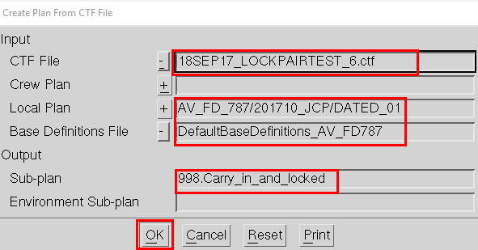

|  |  |
| --- | --- |
| Field | Definition |
| CTF File | CTF File with carry ins and locked pairings generated from NLC. (Ex. 18SEP17_LOCKPAIRTEST_6.ctf) |
| Crew Plan | Not used in pairings. |
| Base Definitions File | BaseDef-Files, there is one for each problem per COA. (Ex. DefaultBaseDefinitions_AV_FD787) |
| Local Plan | Name and path of the Local plan (JCP prefix means Jeppesen Crew Pairing). The name of the Local plan is composed by three parts separated by a “/”. (Ex. AV_FD_787/201710_JCP/DATED_1) |
| Sub-plan | First sub-plan. (Ex. 998.Carry_in_and_locked) |
| Environment Sub-plan | Not used in pairings |

1. Check the info window

**Warnings** on the window may refer to data or tables inconsistency but the subplan will be created with them.

If any Legs used by a Trip on the CTF file is not found on the Local Plan, said Leg will be turned into a NOP (Not Operating Leg), this will be informed on this window and it is very important to fix this Legs before optimizing. See appendix “Fix NOPs” to fix them

**Errors** will stop the Sub-plan creation and it means there is a problem on the CTF data that needs to be fixed

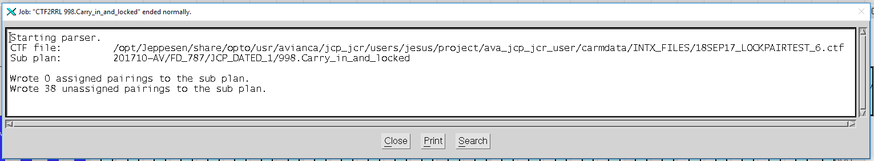

1. Close the info window

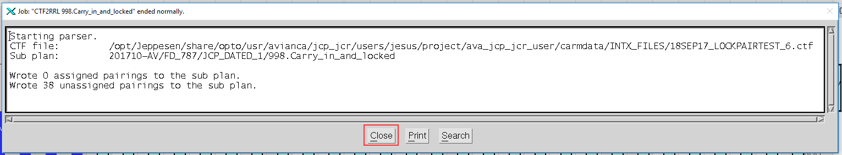

### Fetch the Carry-ins and the Start Sub-Plan and check the legality of the Sub-Plan

#### Create Sub-Plan from CTF file generated from NLC

1. Go to **Planning Tools**(Alt+P)🡪 **Plan Manager**(P) or click to open the **Plan Manager** form



1. Select a **Timetables**/**Versions** folder for the planning area you are working with, and select a local plan to use in the **Local Plans** list, then click on **Open Plan** (Alt+P)

Example: TAI_CA_ALL 🡪 201802_JCP 🡪 DATED_02

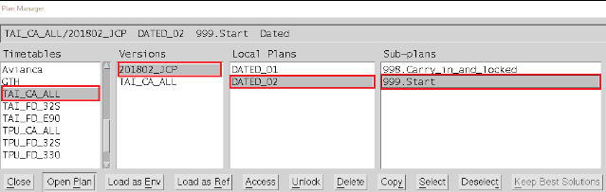

1. **Close** (Alt+C) the **Plan Manager** window

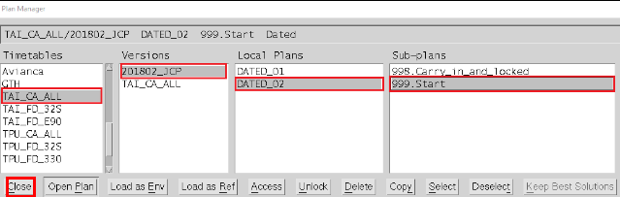

1. Go to **Planning Tools**(Alt+P) 🡪 Sub-plan(S) 🡪 Fetch(F) 🡪 Trips...(T)

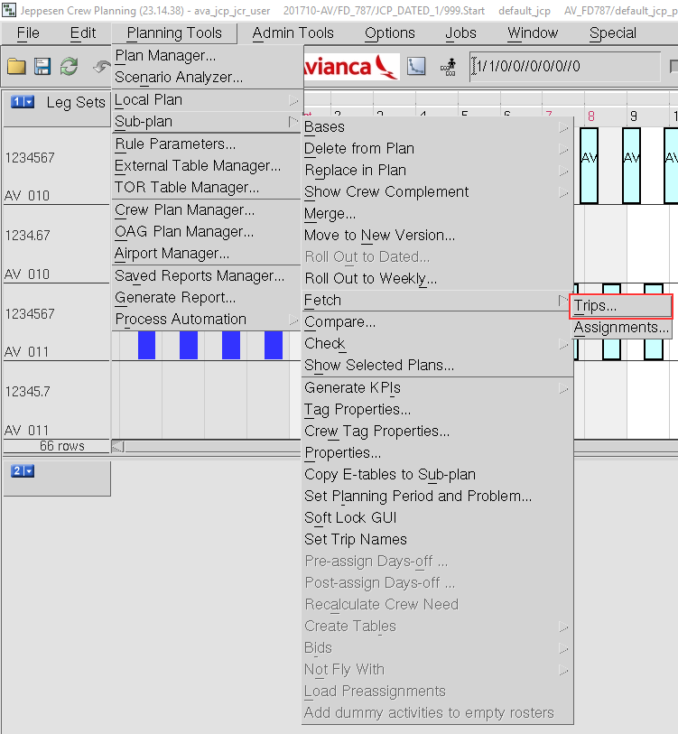

1. In the **Fetch Trips** form, select the tab **Main** and enter the necessary data (marked in red box in the image below) and click **Ok** (Alt+O):

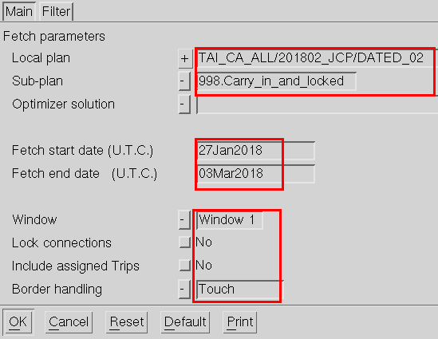

| Field | Definition |
| --- | --- |
| Local plan | Name and path of the Local plan (JCP prefix means Jeppesen Crew Pairing). The name of the Local plan is composed by three parts separated by a “/”. (Ex. TAI_CA_ALL/201802_JCP/DATED_02) |
| Sub-plan | Name of the Sub-Plan that contains the carry ins and the locked pairings. (Ex. 998.Carry_in_and_locked) |
| Fetch start date (U.T.C.) | Start of the planning period minus minimum 3 to 5 days of carry in (5 is recommended), it should be at least the start date of the first assignment on the CTF file that was generated from NLC. (Ex. 27Jan2018) |
| Fetch end date (U.T.C.) | End of the planning period plus minimum 3 to 5 days of carry in (5 is recommended), it should be at minimum the end date of the last assignment on the CTF file that was generated from NLC. (Ex. 03Mar2018) |
| Window | Window where the fetched trips will be shown. (Ex. Window 1) |
| Border handling | Borders definition that will be Fetched to the Sub-plan, touched fetches everything that touches the planning period. (Ex. Touch) |

1. A **Message** window will open to show **Fetch Information** for further review

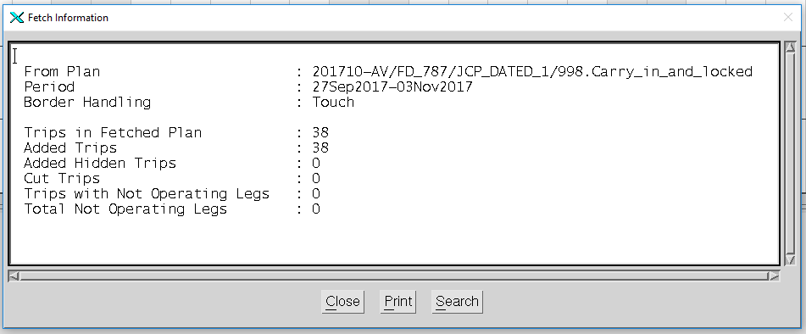

1. Once the information is analyzed, click on **Close** (Alt+O) to continue.

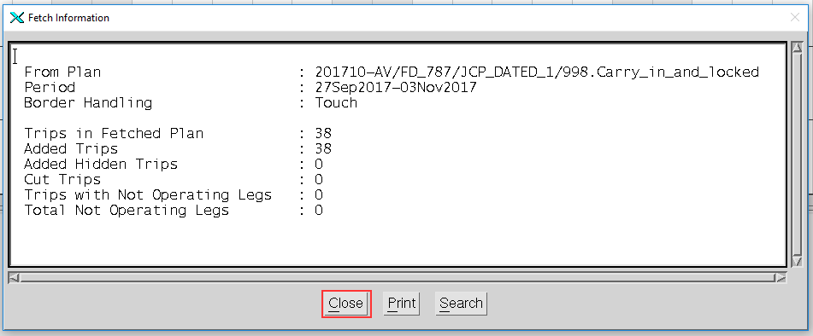

1. Click on **Window 1** icon and select to **Show Trips** (or press F8)

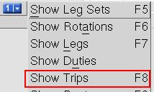

1. Right click on the **Window 1** area (Not on a Trip) to open the **Trips** General menu, then select Filter 🡪 by...(b), (or press **Ctrl+F**)

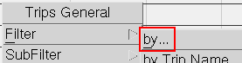

1. In **Trip Filter** form, click on **Default** button (Alt+D); in Select option, set **Leg**; in **Not Operating** field, enter ‘YES’; click on **Ok** button (Alt+O). If any Trip is displayed, go to Step 11, else, skip to Step 12

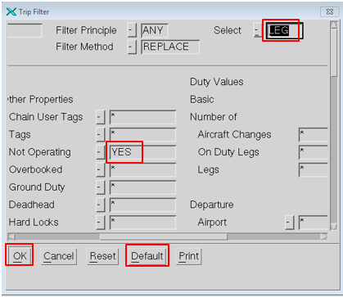

1. Right click on a **Trip** on **Window 1** to open the **Trip Object** menu, and select **Delete 🡪 from Sub-plan**

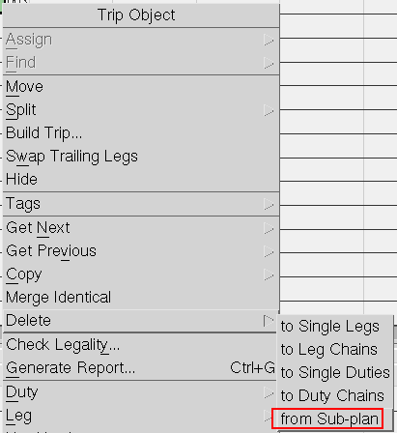

1. Choose Deleting completely from Sub-plan

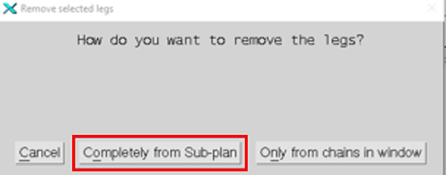

1. Choose Yes about to remove hardlocks

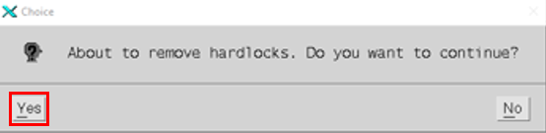

1. Right click on the **Window 1** area (Not on a Trip) to open the **Trips General** menu, then select **Reveal All Trips**

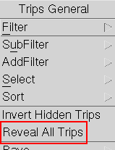

1. Right click on a **Trip** on **Window 1** to open the **Trip Object** menu, and select **Hard Locks**(H)**🡪 Set...**

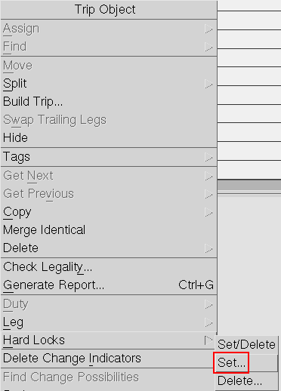

1. In the **Set Hard locks on selected legs** form, set Everywhere in **Leg to leg** field, and Yes in **First leg** and **Last leg** fields, then Click **Ok** (Alt+O) to continue.

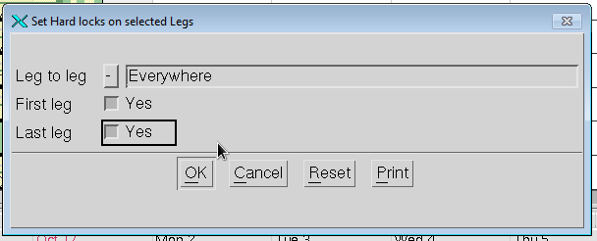

1. Go to **File**(Alt+F) **🡪 Save**(S) and select to **Save Sub-Plan**(S)

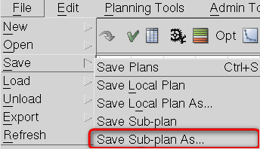

1. In the **Sub-Plan Properties** form, enter an appropriate descriptive name in **Sub-Plan name** field, and the appropriate AOC in **Airline** field, also modify the value for **Crew Complement Assign** fields.

Although it not required, it is highly recommended to enter a descriptive description in Sub-plan comment field, to keep track of the previous saves in case it is the need to go to a previous sub-plan.

After the information is entered, click on Ok (Alt+O) to continue.

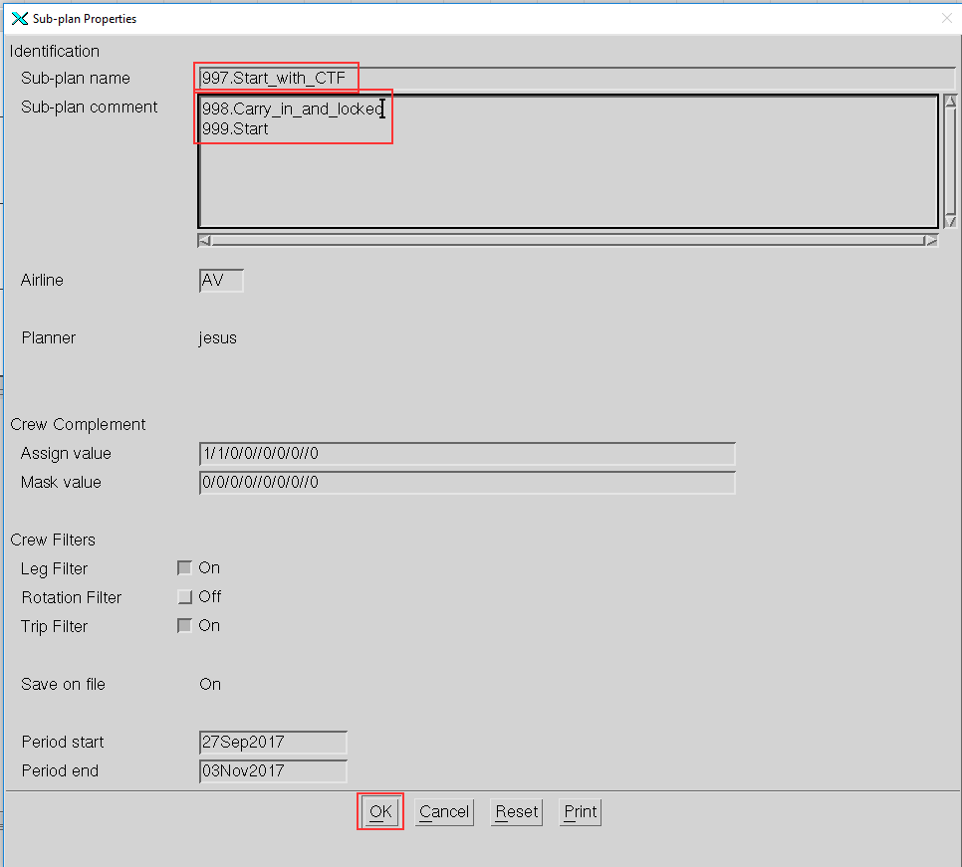

#### **Check Sub-plan Legality**

1. Click on **Window 1** icon, then select Show Legal/Illegal(g) 🡪 Show Illegal Trips(r)

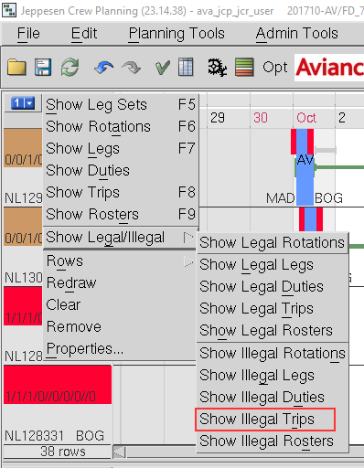

1. *Illegal trips* are shown with a red line on the trip description



1. Right click on the **Window 1** area (Not on a Trip) to open the **Trips General** menu, then go to Select 🡪 All

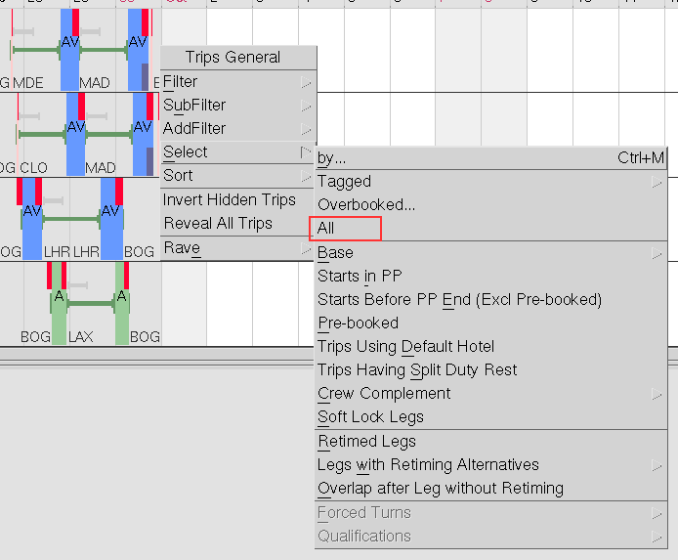

1. Right click on a **Trip** on **Window 1** to open the **Trip Object** menu, and select **Check Legality**

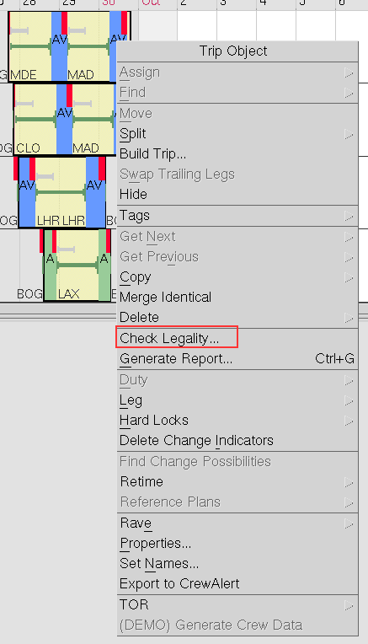

1. A **Message** window will open listing the illegal trips, to review the illegalities by rule, click on **Rule** hyperlink, in the **View** options (top right)

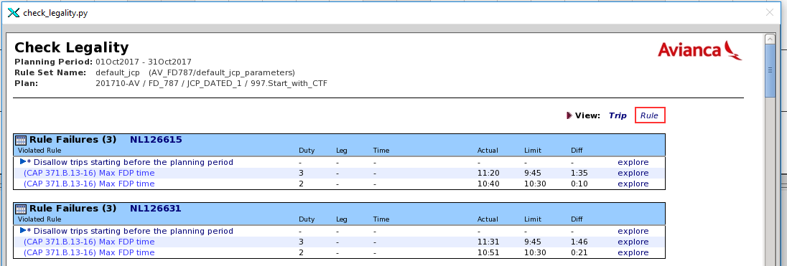

The illegalities grouped by group may help to focus on a group of trips and solve the illegalities more efficiently

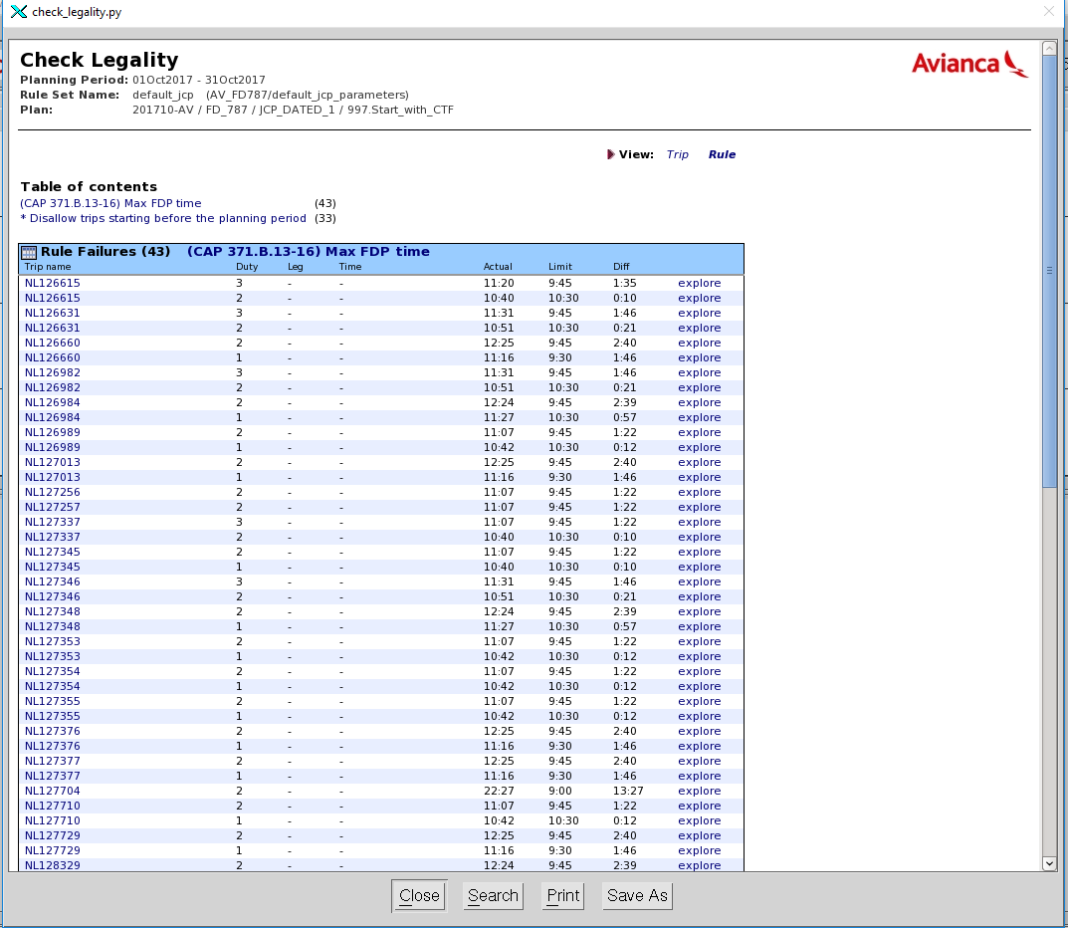

If the trip is constructed as it should be -regardless the illegal condition-, leave it hard locked.

1. A Hard Lock will be shown as a red block should be seen at the trip start, trip end and at leg end of every connection

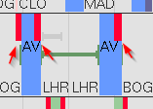

**Hide carry-in trips**

1. Click on **Window 1** icon and select to **Show Trips** (or press F8)



1. Right click on the **Window 2** area (Not on a Leg) to open the **Leg General** menu, then go to Select 🡪 ALL

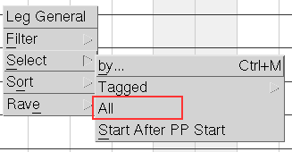

1. To hide *Carry in* *Trips*, right click on the selected trip(s) to open the **Trip Object** menu, and select **Hide**

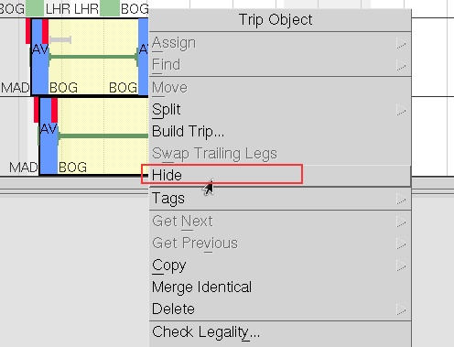

Click on **Window 1** icon and select to **Show Trips** (or press F8)



1. Go to **File**(Alt+F) **🡪 Save**(S) and select **Save Sub-Plan As...**

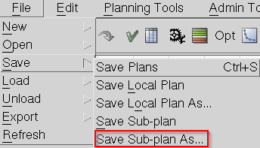

1. In the **Sub-plan Properties** form, enter an appropriate descriptive name (with the next number in the sequence) in **Sub-Plan name** field (Name example: 996.Carry_in_hidden), and the appropriate COA in **Airline** field, also modify the value for **Crew Complement Assign** fields.

Although it not required, it is highly recommended to enter a descriptive description in Sub-plan comment field, to keep track of the previous saves in case it is the need to go to a previous sub-plan.

After the information is entered, click on Ok (Alt+O) to continue

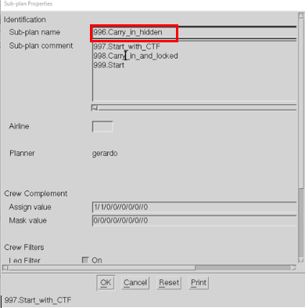

### Create trips

Create trips from the Legs on the Sub-Plan

1. For Cabin Crew, repeat steps 3 to 7 until all the required crew need have been completed.
2. Check the e-table crew_need_coa.etab and identify the slices to be covered by Cabin for all fleets.
3. Below the menu bar on studio is shown the crew need; modify it according to each one of the slice shown below for creating the respective trips on the Subplan:

0/0/0/0//1/2/0//0

0/0/0/0//0/2/0//0

0/0/0/0//0/1/0//0

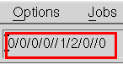

**Note**: In the case you repeat one slice after creating the respective trips, when is used the show legs function, the system function, the system will not send anything because the legs were used for creating trips.

1. Click on **Window 2** icon and select to **Show Leg** (or press **F7**)

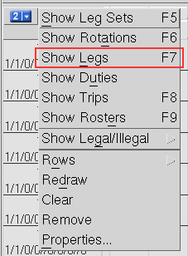

1. Right click on the **Window 2** area (Not on a Leg) to open the **Leg General** menu, then go to Select 🡪 All



1. Right click on a **Leg** on **Window 2** to open the **Leg Object** menu, and select **Create** 🡪 **Trips to** add the Legs to Sub-Plan:

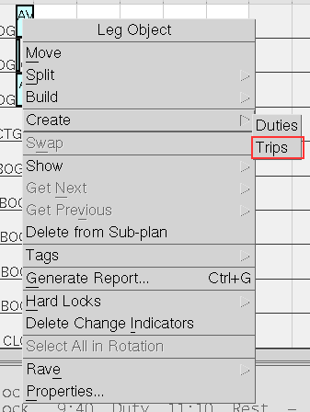

1. **Trip Checks** window will open to inform how many **Legs** were turned into Trips and to request a confirmation, click on **Yes** (Alt+Y) to continue.

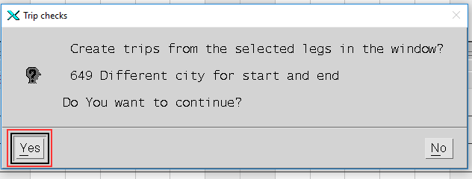

1. Go to **File**(Alt+F) **🡪 Save**(S) and select **Save Sub-Plan As...**



1. In the **Sub-Plan Properties** form, enter an appropriate descriptive name in **Sub-Plan name** field (Ex. 996.Trips_created), and the appropriate COA in **Airline** field, also modify the value for **Crew Complement Assign** fields.

Although it not required, it is highly recommended to enter a descriptive description in Sub-plan comment field, to keep track of the previous saves in case it is the need to go to a previous sub-plan.

After the information is entered, click on Ok (Alt+O) to continue

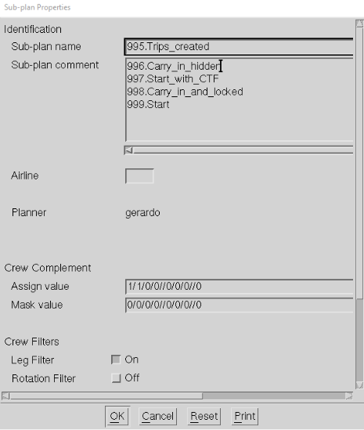

## 

### Preparing Optimization

### Prepare data for Optimizing

Prepare ETABs depending on your planning area

1. 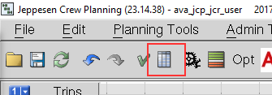Go to **Planning Tools (Alt+P)** 🡪 **External Table Manager (E)** or, on the toolbar, click on to open External Table Manager

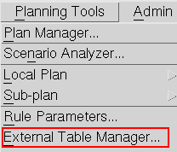

1. In the **External Table Manager** form, select the **Directory** Sub-plan tables to list the etables available in **File**, select an etab to work with, and then click on **Edit** (Alt+E) to continue.

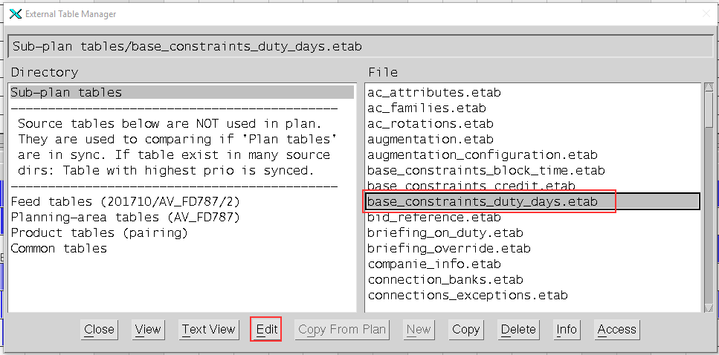

Some etabs that usually edited are:

base_constraints_duty_days.etab

international_layovers_bc.etab

allow_or_restrict_destinations.etab

max_heavy_duties_per_base.etab

debriefing_override.etab

max_connection_time_override.etab

1. Although etabs may have different structures between them, all of them could be updated following the next steps: edit the values shown in red box labeled with (1), click on **Save** icon (2) and then close the **Table Editor** (3).

Example with base_constraints_duty_days.etab FD_32S

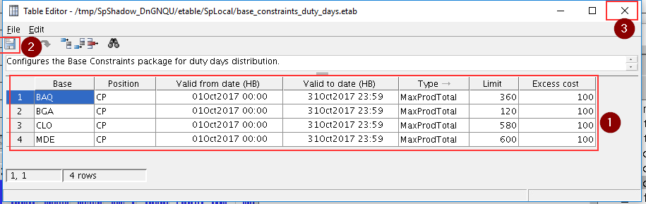

Example with international_layovers_bc.etab FD_32S

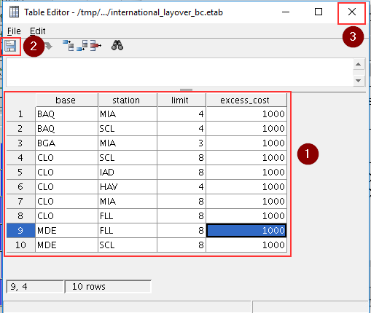

Example with max_heavy_duties_per_base.etab FD_32S

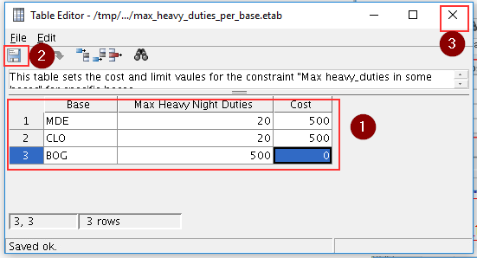

1. Once the necessary etabs has been edited, click on Close (Alt+C) to continue

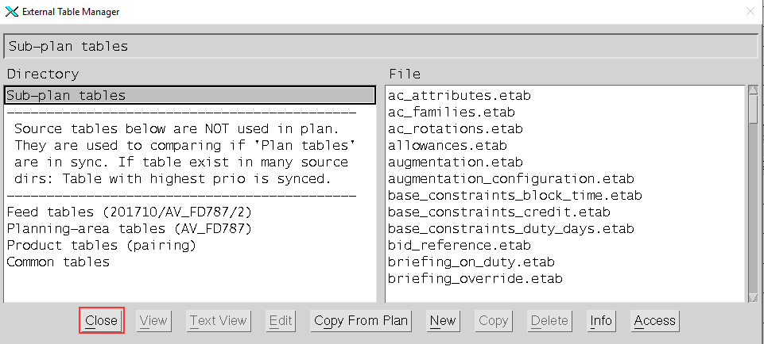

1. To update the changes in the etabs, go to File(Alt+F) 🡪 Refresh(R), or in the toolbar, click on refresh icon

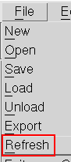

**Prepare Leg Sets if needed –**

**The next steps do not apply to TA or T0, skip to 3.Optimizing section.**

1. Click on **Window 2** icon and select to **Show Leg Sets** (or press **F5**)



1. Right click on the **Window 2** area (Not on a Leg Set) to open the **Leg Set General** menu, then go to Filter 🡪 by... (or press Ctrl+F)



1. In **Leg Set Filter** form, (1) click on **Default** button (Alt+D); (2) in Select option, set Leg; (3) in **Flight Number** field, enter ‘265’ (or flight number that is required); (4) click on **Ok** button (Alt+O).

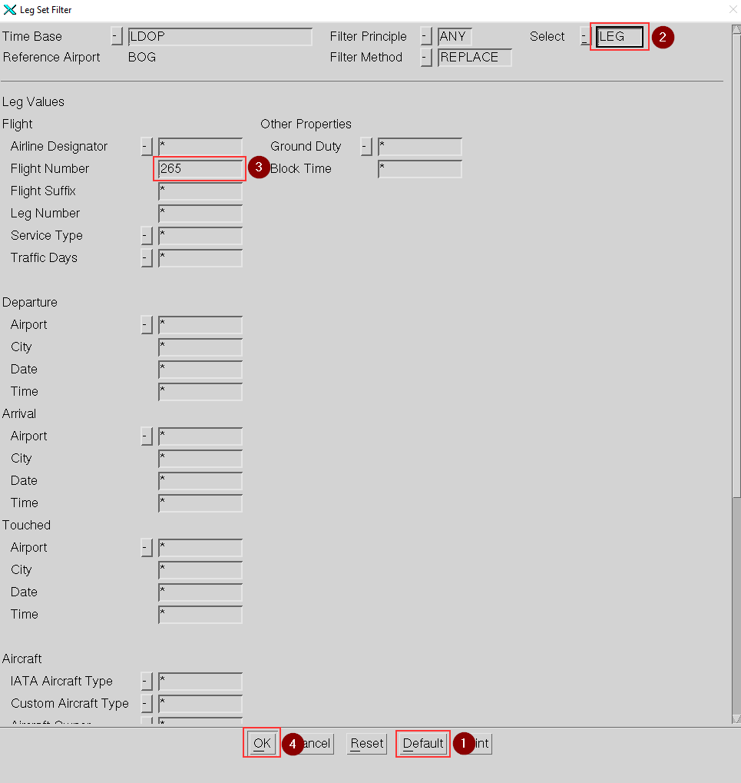

1. Right click on a Leg Set to open the **Leg Set Object** menu and select **Properties** (P)

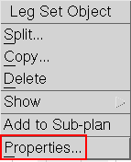

1. In the **Flight Duty Leg Set Properties** form, update the values of the selected flight(s), once the new value is entered, click on **Ok** (Alt+O) to continue

In the images below, the **Arrival** field for **Flight id** AV 265 is updated from 0451 to 0501

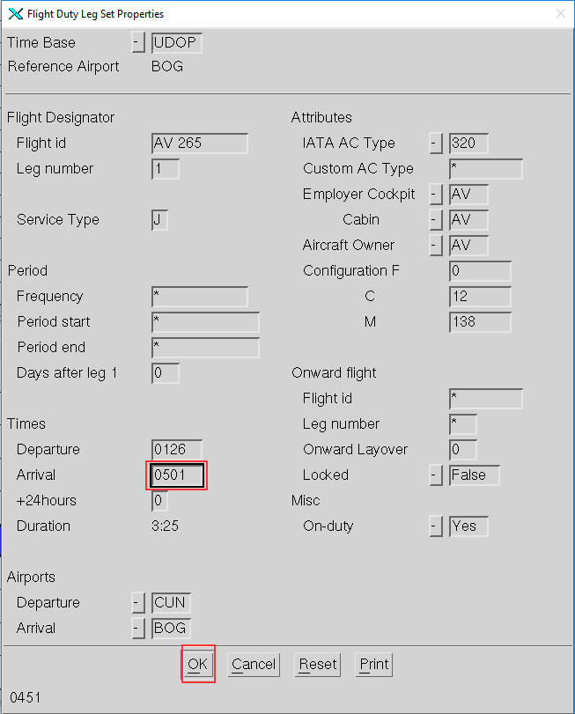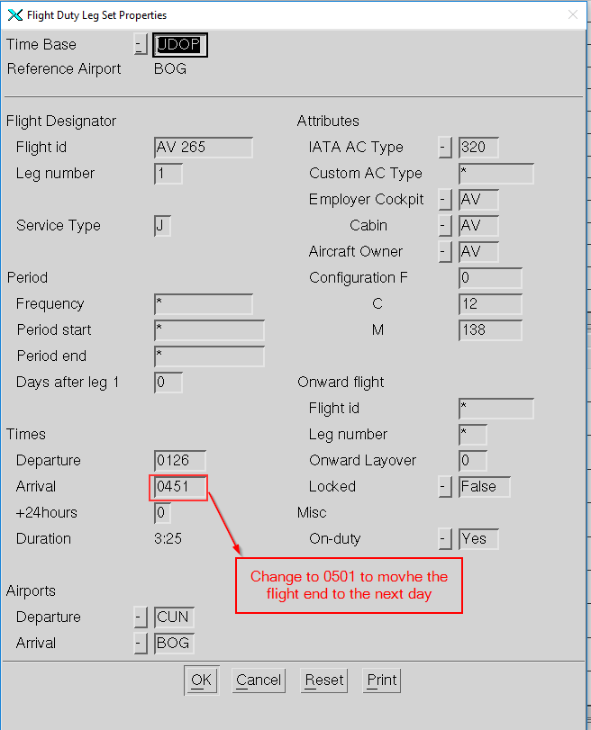

1. Go to **File** (Alt+F) **🡪 Save**(S) and select to **Save Local Plan**(L)



### Optimize by Phases (Applicable to AVA FD_320)

The FD_320 is solved in four previous optimization phases. Before launch the general optimization.

#### Optimization Phase 1: Training Flights for PSO

The input for this optimization run should only contain only flights for PSO.

1. Click on **Window 1** icon and select to **Show Trips** (or press F8)



1. Right click on the **Window 1** area (Not on a Trip) to open the **Trips General** menu, then select **Filter 🡪 by...**(b), (or press **Ctrl+F**)



1. In **Trip Filter** form: (1) click on **Default** button (Alt+D); (2) in **Touched | Date** field, enter ‘PSO’; (3) click on **Ok** button (Alt+O)
2. Send an optimization run just with PSO and wait for the optimization to be completed.

After the optimization, two types of trips will be generated and two types of hard-locks need to be set.

1. open the **Trips General** menu, then select **Filter 🡪 by...**(b); In **Trip Filter** form: (1) click on **Default** button (Alt+D); (2) in the column **Trip Values**, locate the field **Number of | Legs**, enter ‘2’; (3) click on **Ok** button (Alt+O)
2. Right click on a **Trip** on **Window 1** to open the **Trip Object** menu, and select **Hard Locks**(H)**🡪 Set...**; In the **Set Hard locks on selected legs** form, set Everywhere in **Leg to leg** field, and No in **First leg** and **Last leg** fields, then Click **Ok** (Alt+O) to continue.

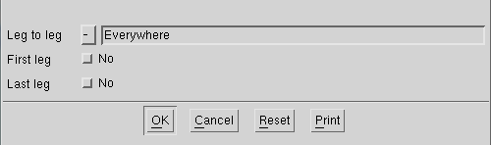

For PSO with only 2 legs, set hard-locks just for the connection, as shown below:



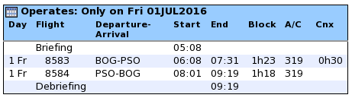

For the rest of PSO trips should be as follows:



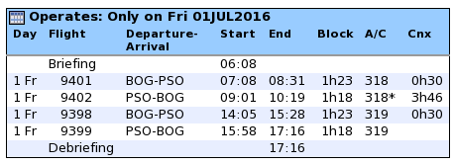

1. Set hard-locks everywhere for these type of training trips.

#### Optimization Phase 2: Hard-locking for CUN

1. There are only two daily flights in CUN: 256-257 and 264-265.
2. Go to the Basic Rules tab and change the following rules (only for the CUN locks for pilots)

from On to Off: Max duty time

from On to Off: AV Maximum duty time in any continuous 24-hour period

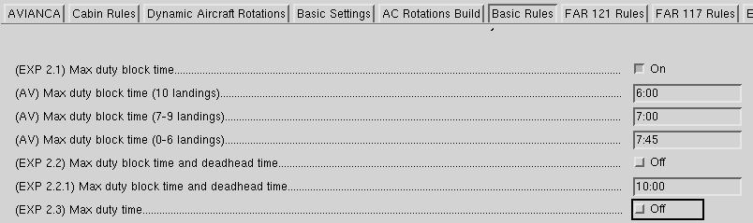

1. Send an optimization run and wait for it to be completed.
2. Set Hard Locks CUN flights.
3. Set the rule back to On

#### Optimization Phase 3: Charter Flights

1. Filter for flights with a Service Type C.

These are one day trips that must return to leaving and returning to base.

1. One way to get the right charter flights is to use the filters as follows:

Service Type “C” and !PEI (any other charter not returning to base)

The trick is to send only the “C” and !PEI to run,

1. One more thing, before sending the run, change the following rule – located under the AVIANCA tab

Max number of legs when at least one leg is charter

must be set to 2

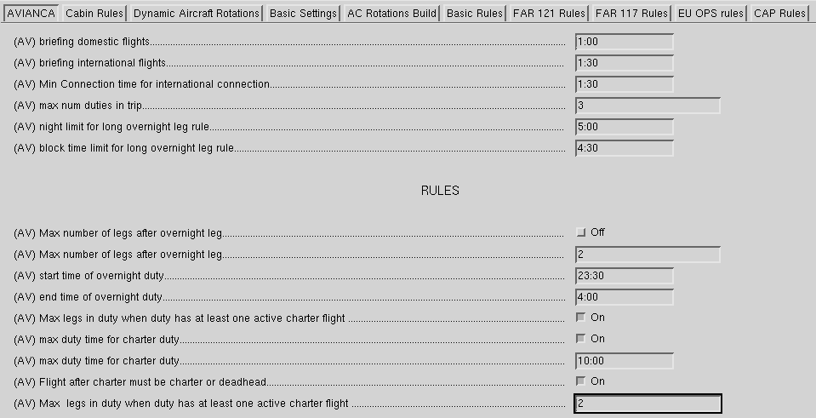

1. Send an optimization run and wait for it to be completed.
2. Once Optimization Phase 3 is completed, make sure the Max number of legs when at least one leg is charter must be set back to 3.
3. As for the PEI (charter types, there is nothing else to about this), these charter legs will go together, there is no need to set any type of locks to ensure connections, the optimizer will take care of this later - you can double check the expected output in the June solution.

#### Optimization Phase 4: JFK Flights

The Trips to JFK are planned according to the requested by AV (Aug.2017):

1. Check the given table (vary from month to month)

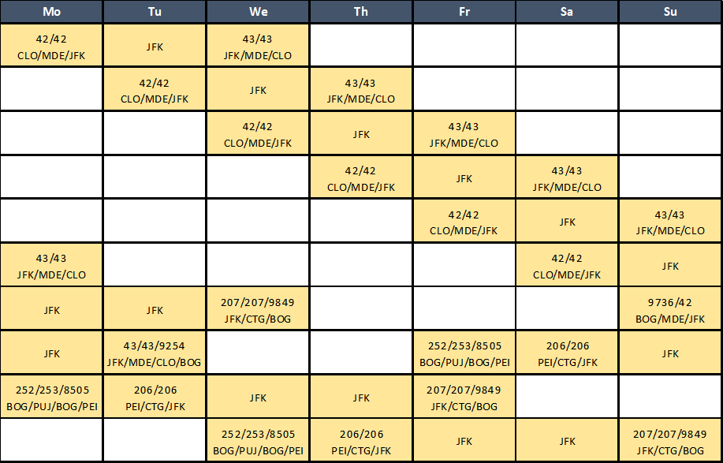

1. Flights AV004/AV009 are planned as requested by AV (April 2017):
2. BGA AV004 tue / AV009 wed (one per week) (DH9461-004//009-DH9472)
3. Finishing the above, all the rest of trips of the team A320,319,318 are launched to complete the first final solution.

### Optimizing

#### If you are going to optimize by parts you must filter each part that you want to optimize in this section and then join all the solutions

#### Optimizing

1. Go to **File**(Alt+F) **🡪 Save**(S) and select **Save Sub-Plan As...**

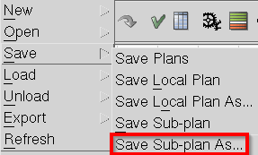

1. In the **Sub-plan Properties** form, enter an appropriate descriptive name (with the next number in the sequence) in **Sub-Plan name** field (Name example: 994.Start_pre_opt), and the appropriate AOC in **Airline** field, also modify the value for **Crew Complement Assign** fields.

Although it not required, it is highly recommended to enter a descriptive description in Sub-plan comment field, to keep track of the previous saves in case it is the need to go to a previous sub-plan.

After the information is entered, click on Ok (Alt+O) to continue

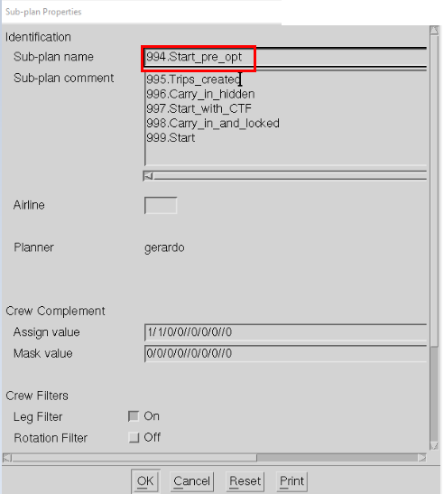

1. Click on **Window 1** icon and select to **Show Trips** (or press F8)

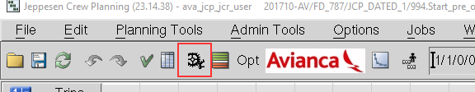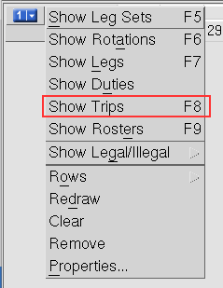

1. Go to Jobs(Alt+J) 🡪 Start Optimization Job or click on

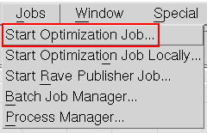

1. In the **Start Optimization Job** form, (1) in **Sub-plan name** field and enter a name for the sub-plan that will be created with the optimization results, (2) in **Input legs/rotations** select the window that contain the trips to be optimized, (3) in the **Optimizer** field, set Crew Pairing Optimizer, (4), set 4 (preferably)in **Slots** field, click **Ok**(Alt+O) to continue.

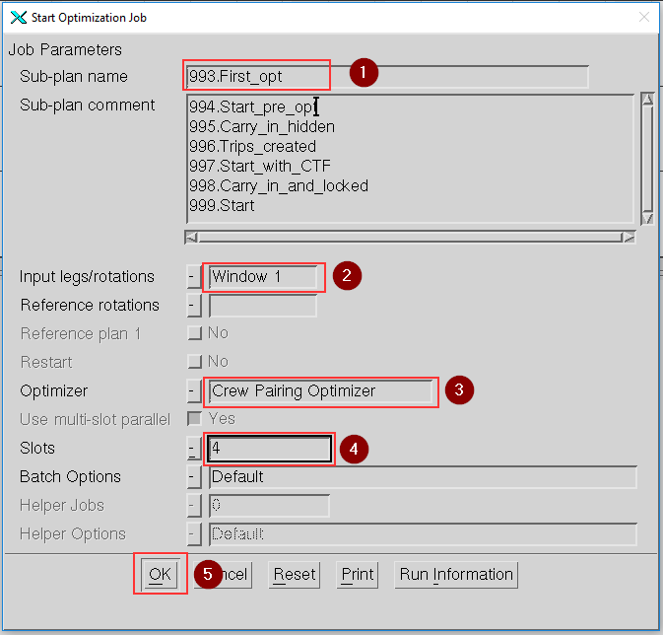

1. The **Optimization Job** may take several time to be completed, depending on the number of trips and the workload, but once it finish, a Message window will open to inform that the job has ended, select **Close**(Alt+C) to continue.

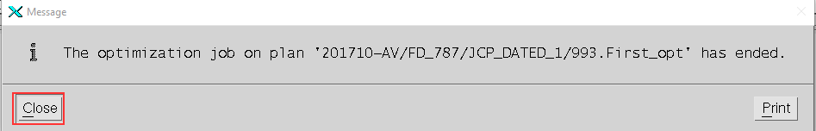

#### Open the optimized solution

1. Open the Plan Manager, select the Sub-plan that was optimized, from the Solutions list, select a optimization solution (Best solution takes the cheapest solution with less unassigned trips)

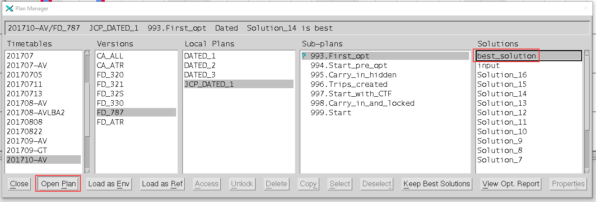

1. Click on **Window 1** icon and select to **Show Trips** (or press F8)



#### Check the solution

1. Go to **File**(Alt+F) **🡪 Save**(S) and select **Save Sub-Plan As...**

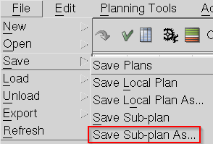

A Choice window may open asking to save Sub-Plan even though no changes have been made, click on Yes (Alt+Y) to continue.

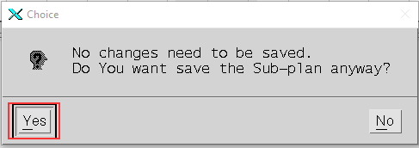

1. In the **Sub-plan Properties** form, enter an appropriate descriptive name (with the next number in the sequence) in **Sub-Plan name** field (Name example: 992.Optimization_job_x), and the appropriate AOC in **Airline** field, also modify the value for **Crew Complement Assign** fields.

Although it not required, it is highly recommended to enter a descriptive description in Sub-plan comment field, to keep track of the previous saves in case it is the need to go to a previous sub-plan.

After the information is entered, click on Ok (Alt+O) to continue

Name example: 992.optimization_job_x (x is the number of optimization you are using

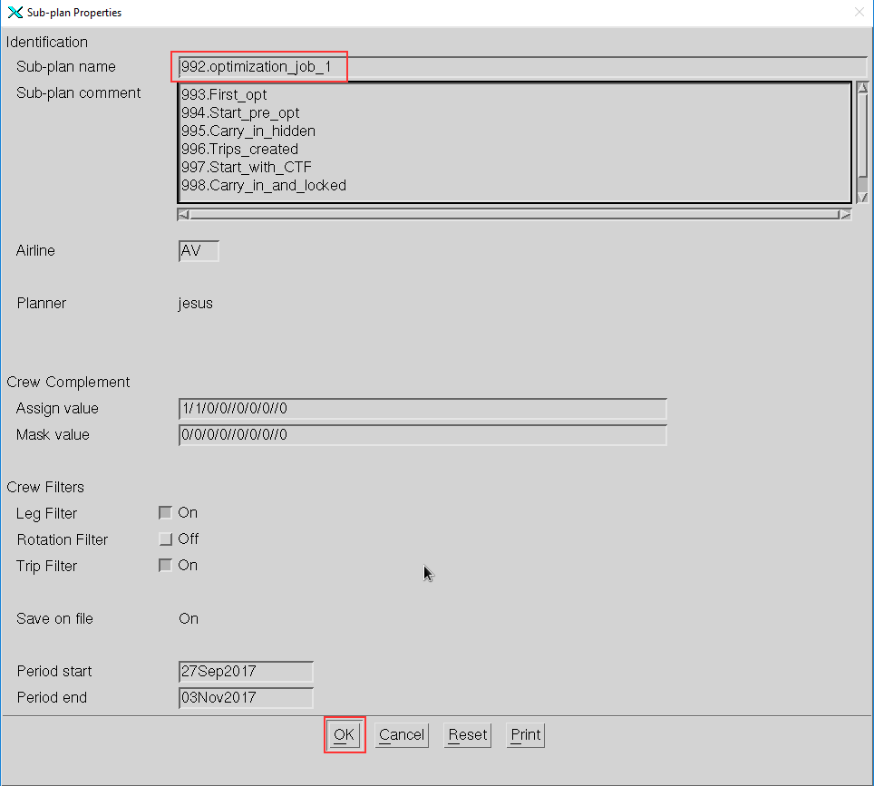

1. In the Trips that the solution built, review that the requirements and specifications of the planning period are completed and that there isn’t any implausible Trips or Single Legs wtihin the planning period

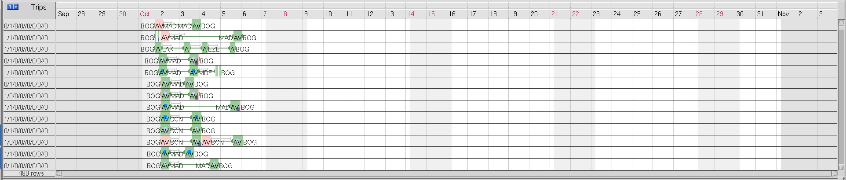

#### Check optimization reports

1. Go to **Planning Tools (Alt+P)** 🡪 **Scenario Analyzer**(n)

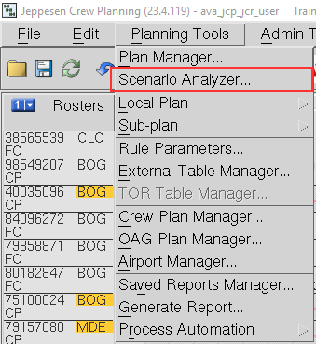

1. Check the desired values on the Scenario Analyzer
2. If you need to, you can manually fix the solution to move or add assignments (This could affect the tagging and you might need to manually fix them)
3. If you have many optimization jobs with different parameters or fixes, select the one to use for production

### Export to Net Line Crew (NLC)

Next, you will find the steps for exporting the solution from Jeppesen Studio to a file with NLC format, that can be copied to your local directory.

#### Save the Final solution

1. Go to **File**(Alt+F) **🡪 Save**(S) and select **Save Sub-Plan As...**



A Choice window may open asking to save Sub-Plan even though no changes have been made, click on Yes (Alt+Y) to continue.



1. In the **Sub-plan Properties** form, enter an appropriate descriptive name (with the next number in the sequence) in **Sub-Plan name** field (Name example: 991.Final_prod_solution_fleet), and the appropriate AOC in Airline field.

Although it not required, it is highly recommended to enter a descriptive description in Sub-plan comment field, to keep track of the previous saves in case it is the need to go to a previous sub-plan.

After the information is entered, click on Ok (Alt+O) to continue

Name example: 991.Final_prod_solution_fleet

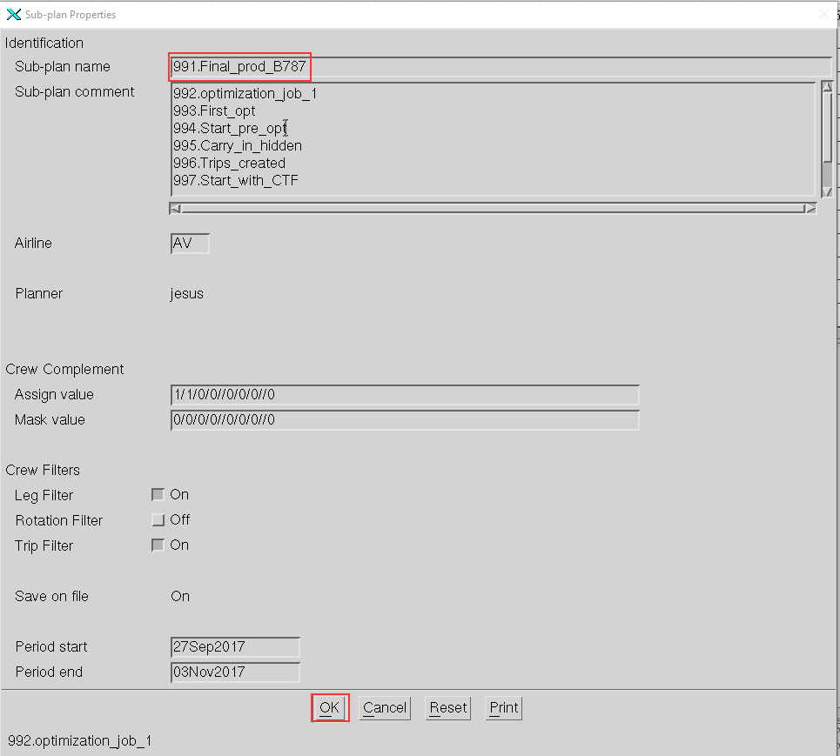

#### Export your final Sub-plan to Net-Line Crew format

1. To Export selected plan to Net Line Crew, go to Planning Tools(Alt+P) **🡪** Process Automation(r) 🡪 Pairing(P) and select Export to NLC

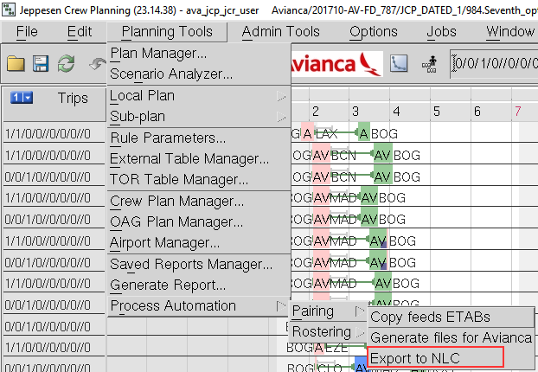

The result of this process are two files: a NLC file with “.nlc” extension and a log file. Both files are located in the folder:

$CARMDATA/OUT_DATA/NLC/Planning_Month(YYYYMMformat)/JCP/COA/

The files are named following the naming convention:

JCP_(COA)_(Category and fleet)_(Version)_(YYYYMMDD_hhmm)_user-name.[nlc|log]

Where

|  |  |
| --- | --- |
| **Variable** | **Value** |
| COA | is one of AV,TA,etc |
| Category | is FD or CC |
| Version | is the version of the feeds etabs defined on the planning period and problem |
| Fleet | is ALL or ATR for CC,  and one of 32S, 330, 787, ATR,E90 for FD |
| YYYYMMDD_hhmm | has the date and time that the file was generated |

Example:

JCP_AV_FD787_2_20171017_1453_jesus.log

JCP_AV_FD787_2_20171017_1453_jesus.nlc

1. A Message Window will inform about the NLC export process, click on Close(Alt+C) to continue.

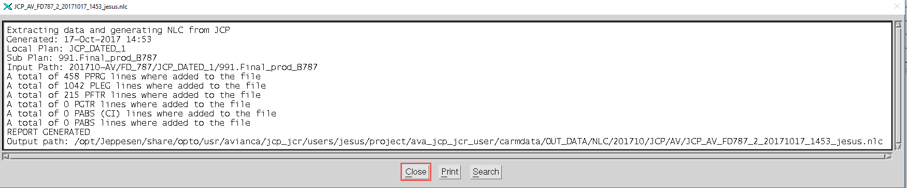

1. Copy the NLC file from the server to the computer

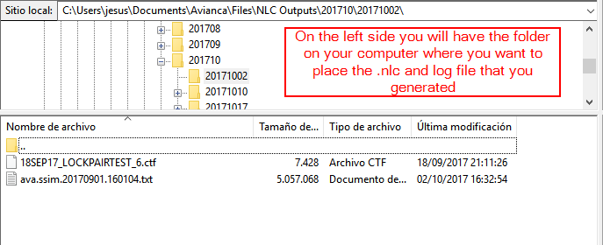

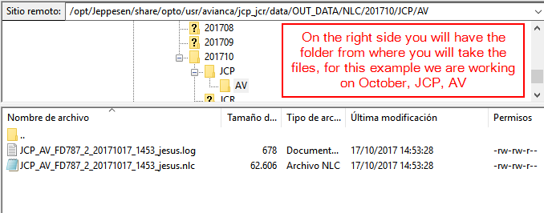

To be sure that you are taking the files you just generated just check on the owner tab (Proprietary) and your user name should appear on both the .log and the .nlc files.

# General Activities

This chapter describes general activities that are used in the planning work flow.

1. Crew Planning User Guide and Carmen help, Studio commands for more information about how to work and interact with Studio.

### Monitoring an Optimization Run

To monitor an optimization job in progress, do the following:

1. Select the command **Planning Tools 🡪 Plan Manager**.
2. In the Plan Manager form, select a solution to monitor. If the job is still running, a notification is displayed in the information field. See example below.

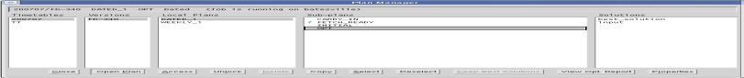

1. Click **View Opt. Report** to display the Optimizer Report form.
2. In the **Solution information** tab, plot **TOTAL cost**.
3. Carmen Help, Studio commands, Plan Manager for more information about how to plot values in the optimizer report.

### Fix NOPs

If you have Not Operating Legs (NOPs) follow the next steps:

1. Identify the NOPs

NOP example (NOPs are shown in a dark blue color)

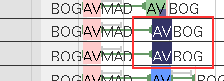

Right click on window 1 (Not on a Trip) 🡪 Trips General 🡪 Filter 🡪 NOP Leg

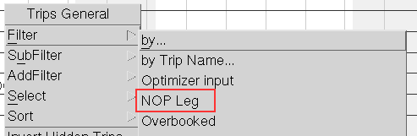

1. Identify the reason for the NOPs and restart the process from the correct step

If the NOPs are shown in the carry ins you must decide delete this pairings and check if this data is good to continue or if this is not useful anymore.

If the NOPs are shown in the planning period or you decided that the data is not useful anymore you must check the data on the NLC system to define if you will continue with the same SSIM and only change the CTF or if you will restart the whole process.

If the Legs that are seen as NOPs are still operational you must restart the process with a new SSIM file and verify that this Legs exist on your new Local Plan, if the Legs are still not shown you must check your SSIM file’s origin and validate the SSIM data.

If the Legs are not going to be operated but are still used on the CTF file you can keep using the Local Plan and change only the CTF file, if the NOPs still appear on the new CTF file you must check the NLC scenario that you are using to create the CTF file.

### Leg Conflict Report

If you get the following message:

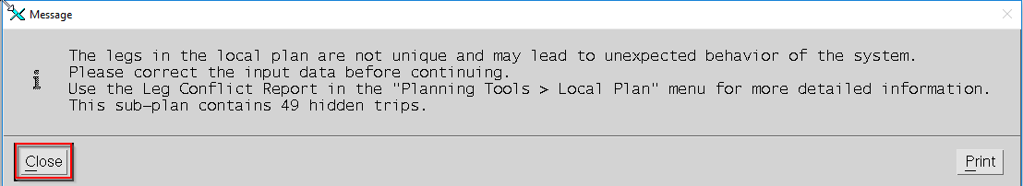

This means that you have two or more leg sets matching the keys of one leg (Carrier, Flight number, Departure date, Departure station), this problem must be checked to validate the reason and if it’s needed generate a new CTF file without this issue

1. Open the Leg Conflict Report

**Planning Tools 🡪 Local Plan 🡪 Leg Conflict Report**

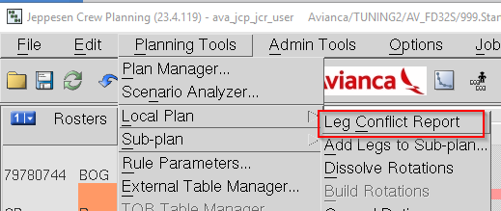

1. Open the Leg Conflict Report

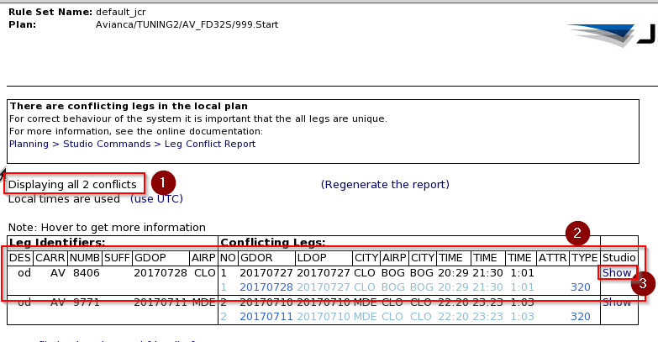

In point number one of the Report we can see how many legs are conflicted

In the box with point number 2 we can see the details of some legs, this legs can sometimes have the same info but since they are written two times on the CTF they generate two leg sets

Click on show, it’s next to point number 3 and we will see the specific leg sets related to the issue

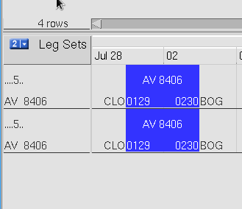

You must check on the tracking system why is this issue generated and solve it, then generate a new CTF and restart this Step by Step with it

# External Table Management

This chapter describes useful procedures for managing external tables.

Usually, all external tables are kept in the sub-plan and local plan. When a sub-plan/local plan is created, the external tables are copied from three different source directories:

* Feed directory:  
  The feed directory holds external tables for a specific planning period. For example, fleet, period, and version. The location of the directory is also specified by fleet, period, and version.
* Default Fleet directory:  
  The Default Fleet directory holds default external tables for a certain fleet. The location of the directory is specified by the fleet.
* Product directory:  
  The product directory holds default external tables for either Pairing or Rostering. The location of the directory is specified by the planning product.
* Default:  
  The default directory holds default external tables for all fleets. The location is irrelevant.

Copying External Tables Between Plans

The table manager (Planning Tools 🡪 Table Manager) allows you to copy external tables from other sub-plans and local plans by selecting a directory and clicking Copy From Plan. The following form is displayed.

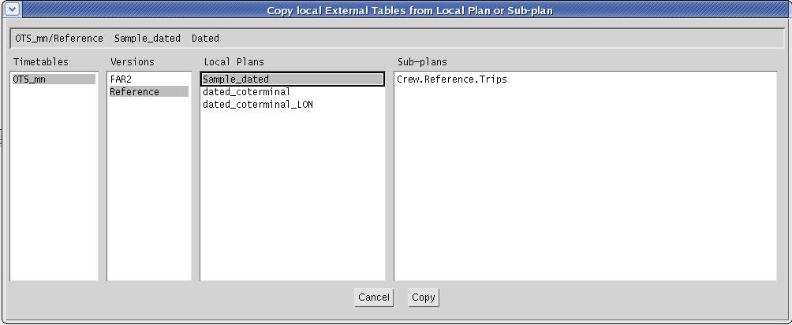

Figure 2: Copy from local plan or sub-plan.

#### Copying External Tables from Another Local Plan

To copy external tables from a local plan, do the following:

1. Select the local plan from which to copy the external tables.
2. Click **Copy**  
   The following form is displayed.

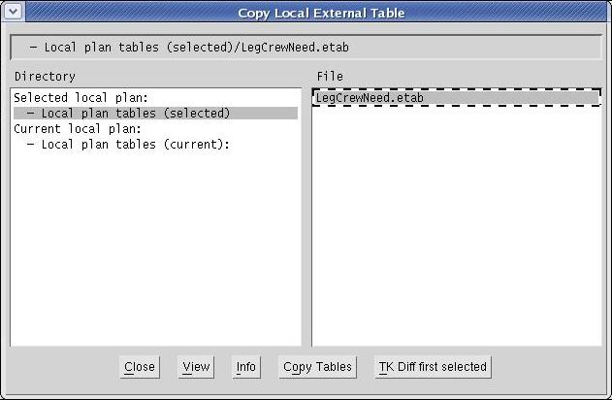

Figure 3: Copy from local plan form.

1. Select **Local plan tables (selected)** and then the external tables that should be copied.
2. Click **Copy Tables** to copy the external tables to the corresponding directory in the current local plan.

|  |  |
| --- | --- |
| *Note* | If an external table already exists in the current local plan, you can view the differences between the tables by clicking TK Diff first selected. If multiple tables are selected, the comparison is done on the topmost of the selected tables. |

#### Copying External Tables from Another Sub-Plan

To copy external tables from a sub-plan, do the following:

1. Select the sub-plan from which to copy the external tables.
2. Click **Copy**  
   The following form is displayed.

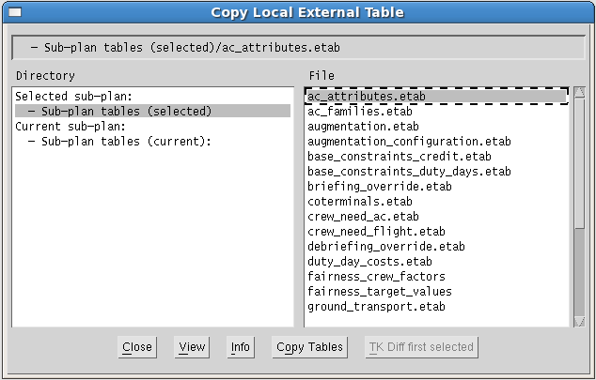

Figure 4: Copy from sub-plan form.

1. Select **Sub-plan tables (selected)** and then the external tables that should be copied.
2. Click **Copy Tables** to copy the external tables to the corresponding directory in the current sub-plan.

|  |  |
| --- | --- |
| *Note* | If an external table already exists in the current sub-plan, you can view the differences between the tables by clicking TK Diff first selected. If multiple tables are selected, the comparison is done on the topmost of the selected tables. |

Exporting External Tables to Source Directory

You can export an external table from a sub-plan back to the source directories where it came from (Default, Default Pairing, Default Fleet, Default Month or Feed). This can only be done if the external tables differ.

1. Press the **notification button** to show the “diff report”.
2. Find the external table to export, and click **Export**.

Importing External Tables to Current Sub-Plan

You can import an external table from the source directory to the sub-plan. This can only be done if the external table is missing in the sub-plan or if the external tables differ.

1. Press the **notification button** to show the “diff report”.
2. Find the external table to import, and click **Import**.

Advanced Copying of External Tables

You can copy external tables from/to a sub-plan to/from any of the different source directories. It is also possible to copy external tables between source directories.

|  |  |
| --- | --- |
| *Note* | It is important to understand the effect of copying external tables to other source directories. This should be done with caution since it impacts future planning! |

1. Open the **Table manager** and select the external table to copy.
2. Click **Copy** and select which directory to copy the external table to.
3. Set the correct name of the external table and click **Ok** (normally just remove _copy part from the name).

# Unix administration

CARMUSR and CARMDATA for AVA JCP prod

$CARMDATA = /opt/Jeppesen/share/ava/data/jcr/prod/ava_jcp_jcr_data_prod

$CARMUSR=

/opt/Jeppesen/share/ava/usr/jcr/prod/ ava_jcp_jcr_usr_prod

Publication data

Publication data will automatically be saved in the following directories:

**$CARMDATA/OUT_DATA/NLC/Planning_Month(YYYYMMformat)/JCP/COA/**

YYYYMM: The working year and month

Linking Timetables between different carmdata

If there is no link between the rostering Timetable directory in the rostering system and the Timetable directory in the old pairing system (see **Error! Reference source not found.**), then the a link must be setup from $CARMDATA/LOCAL_PLAN:

ln –s $CARMDATA/LOCAL_PLAN/new_Timetable

After doing this, you should be able to see this Timetable in your rostering Plan Manager:

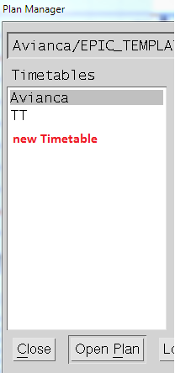

Copying etables between different versions

First go to the feeds directory with the next command

cd $CARMDATA/ETABLES/feeds

Then copy the previous planning period tables to the current planning period with the next command

cp -r YYYYMM(Prev period) YYYYMM(Current period)

Example:

cp -r 201706 201707